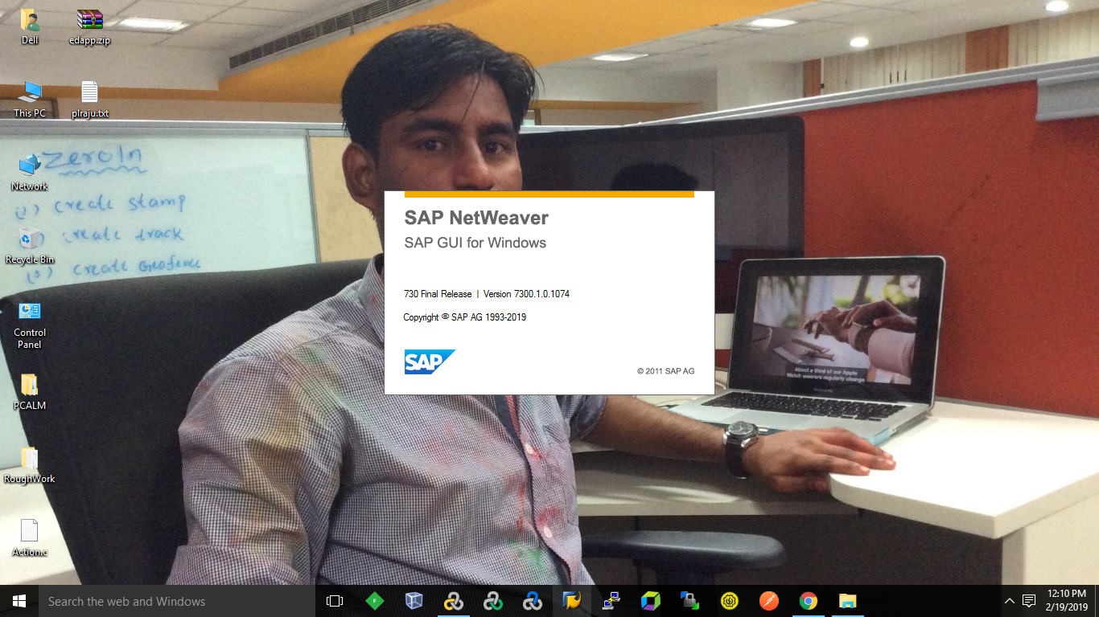

2.Configuration Connection

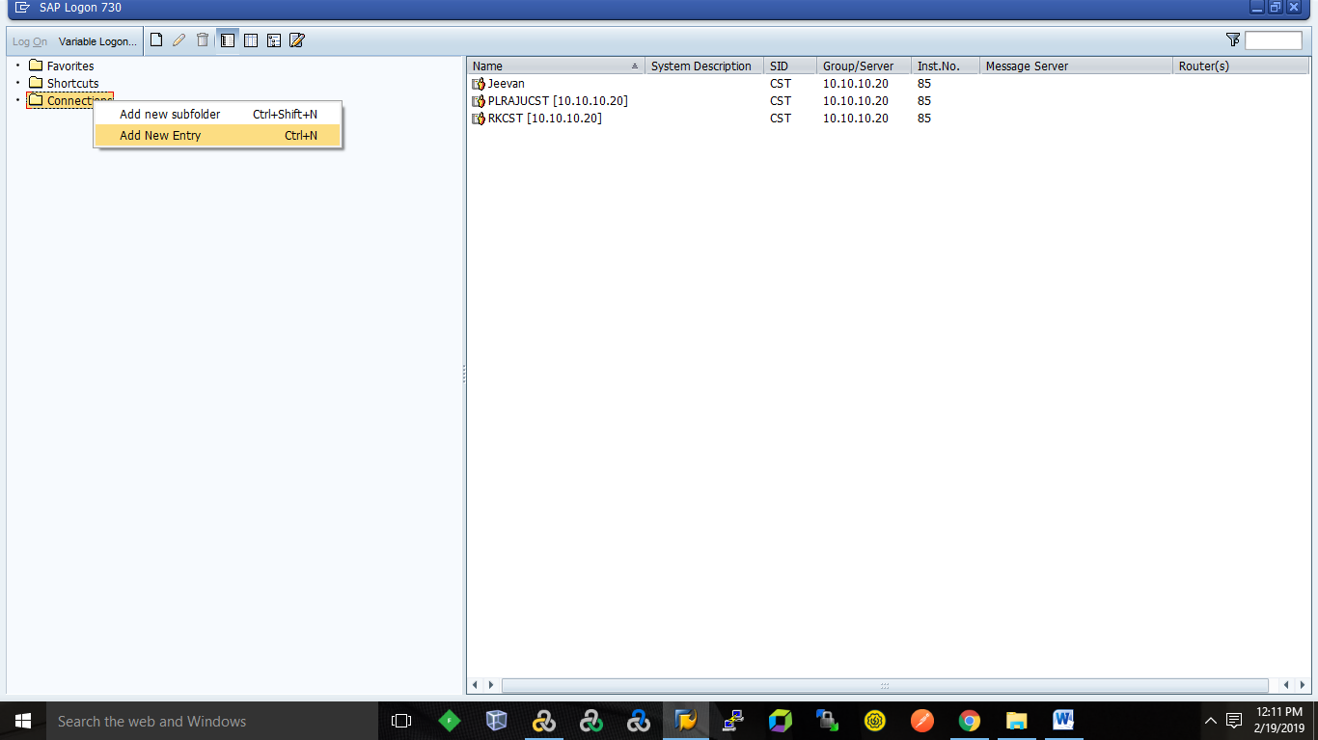

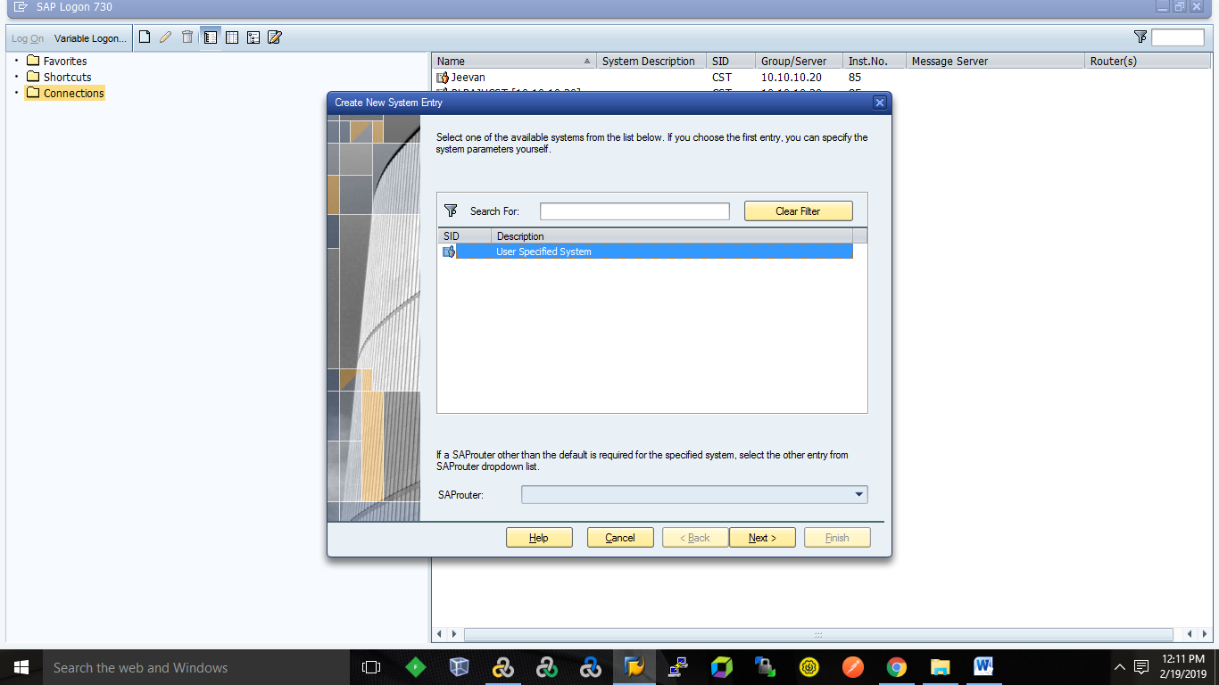

Double click obove user specified system.

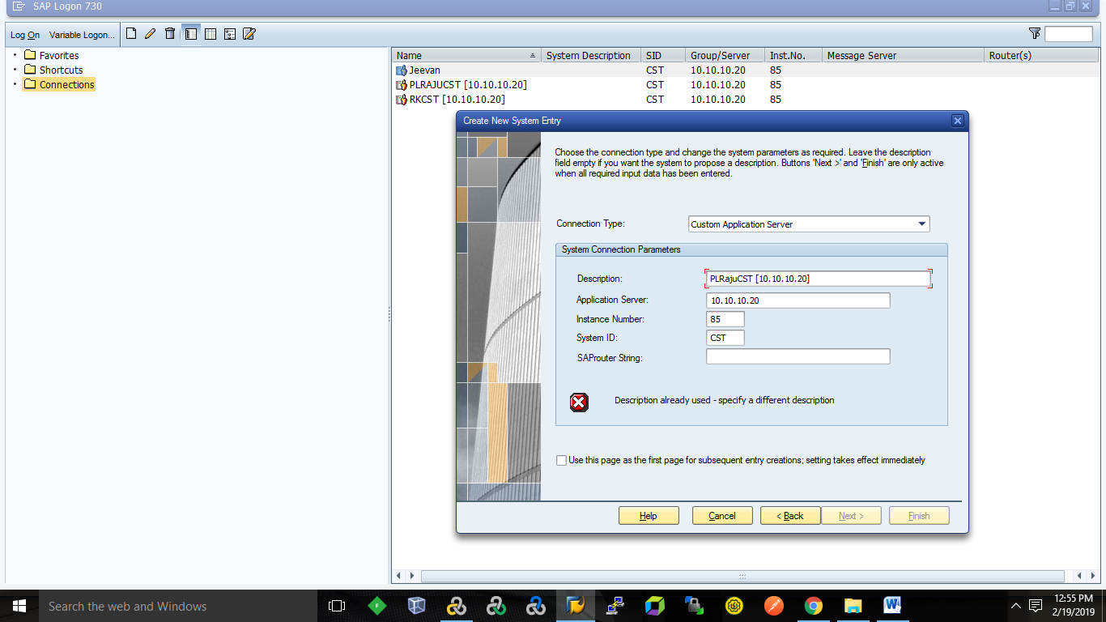

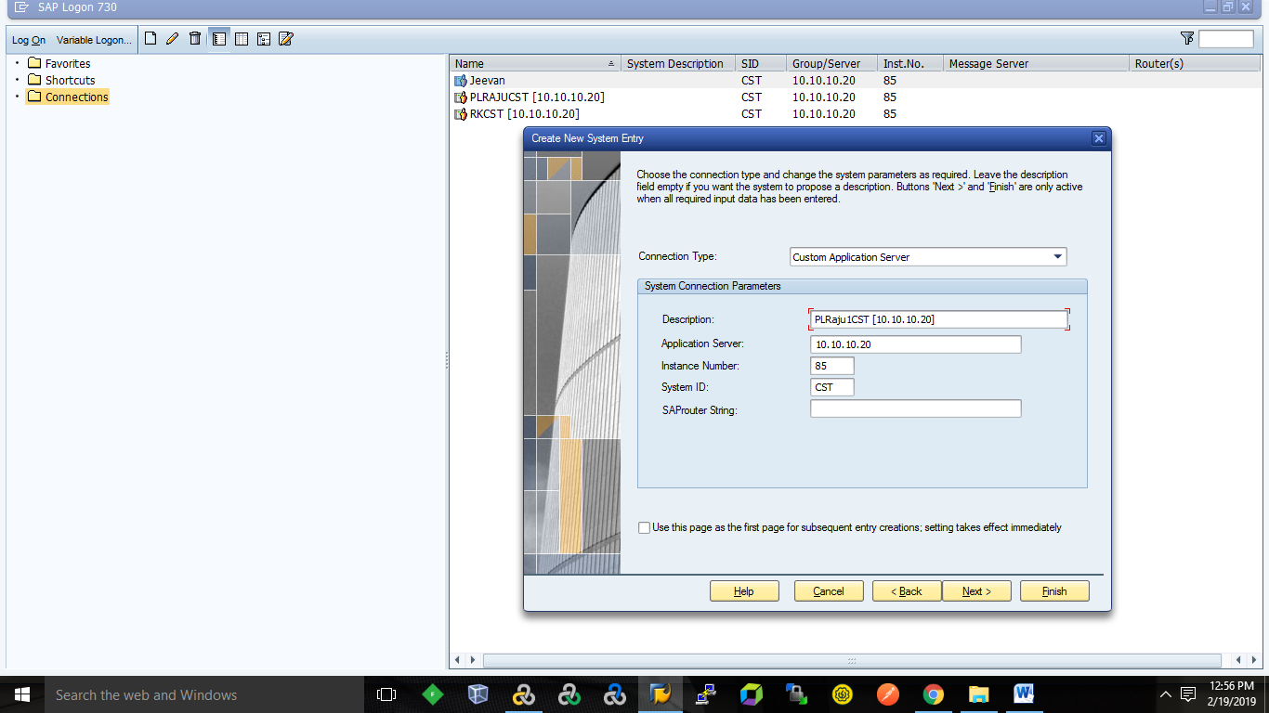

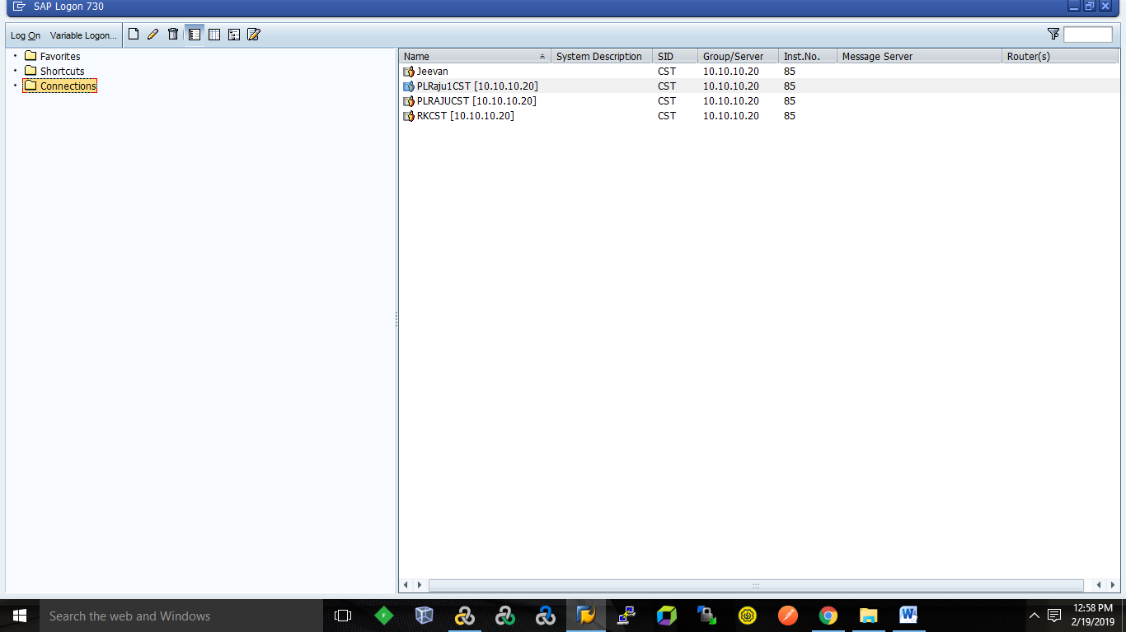

Enable Client Side Scripting

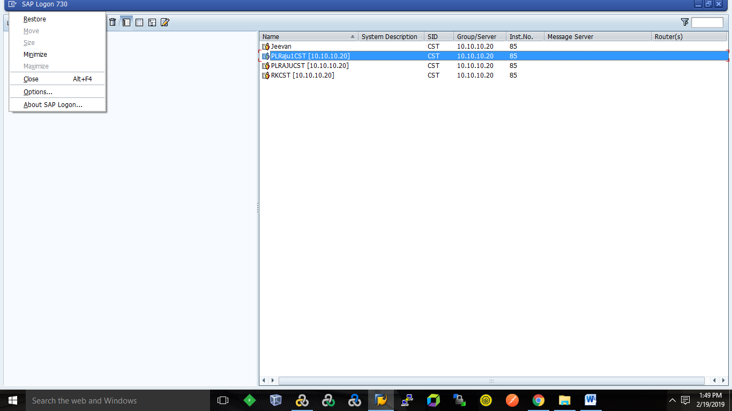

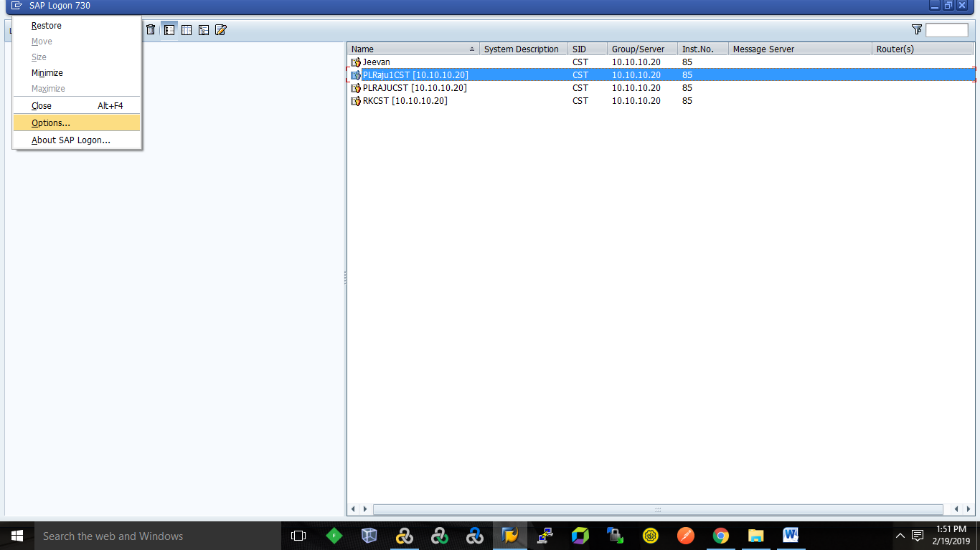

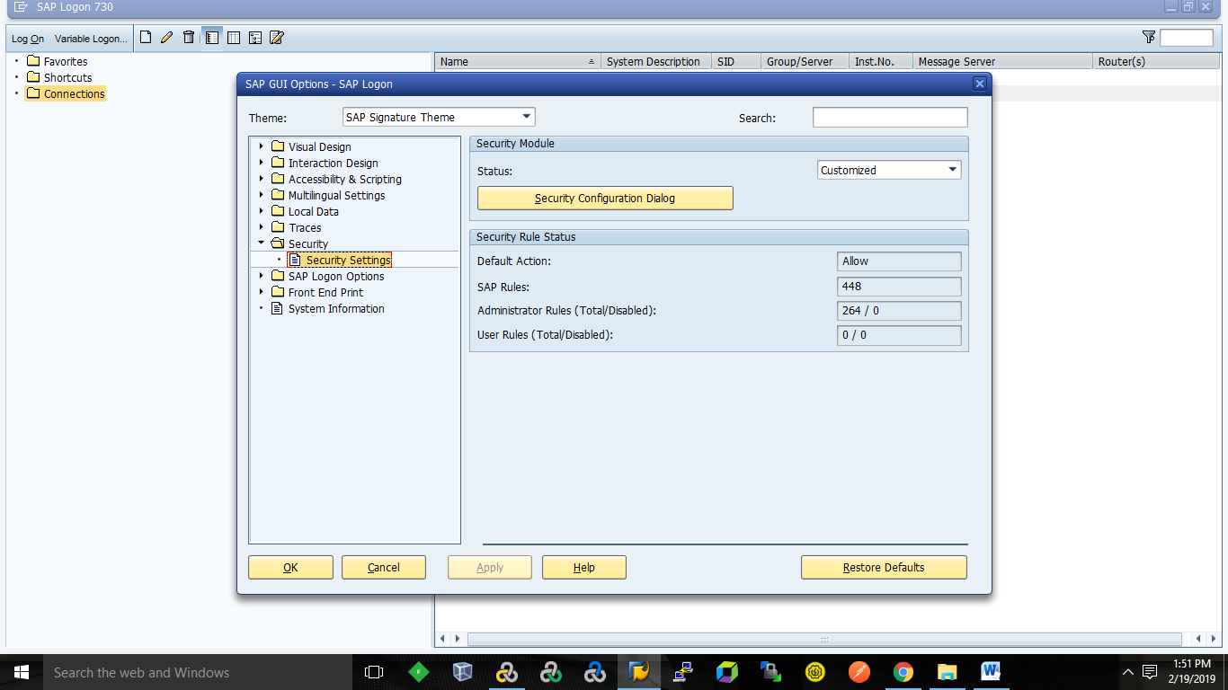

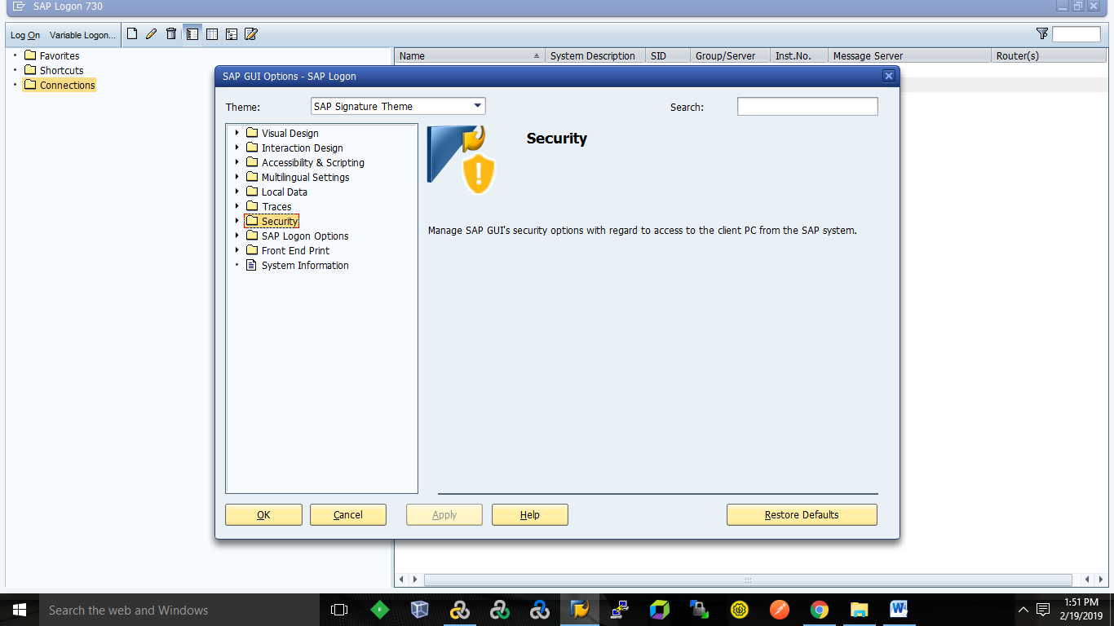

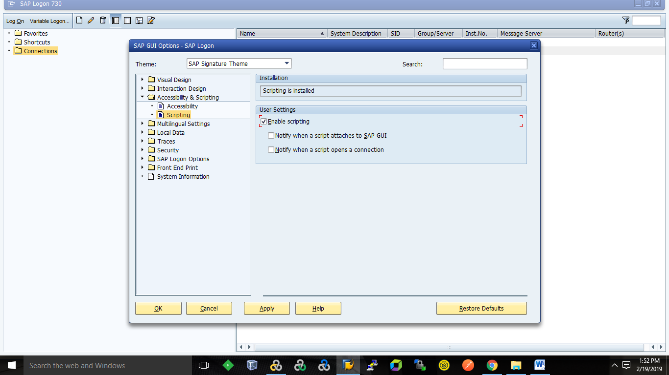

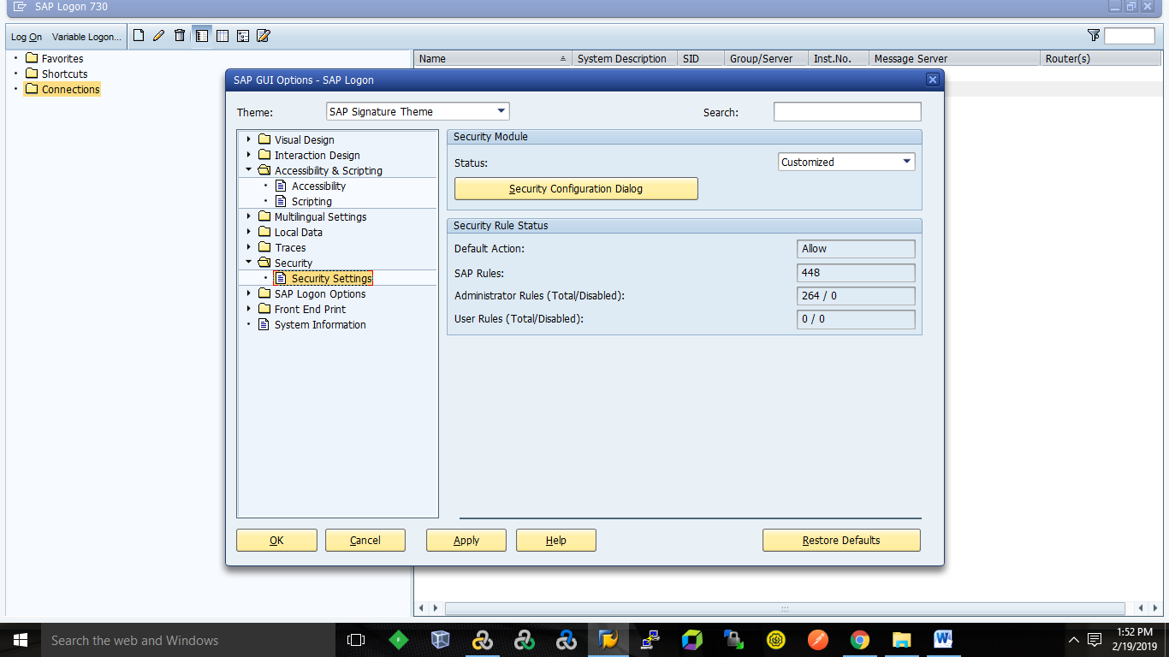

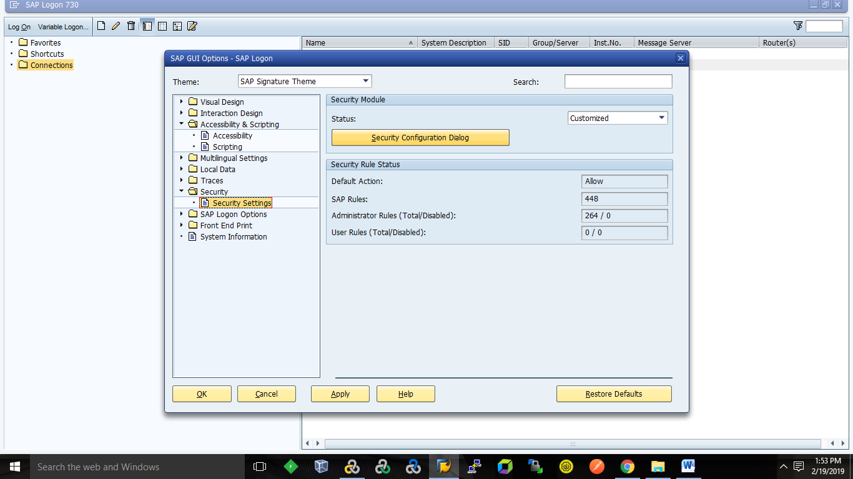

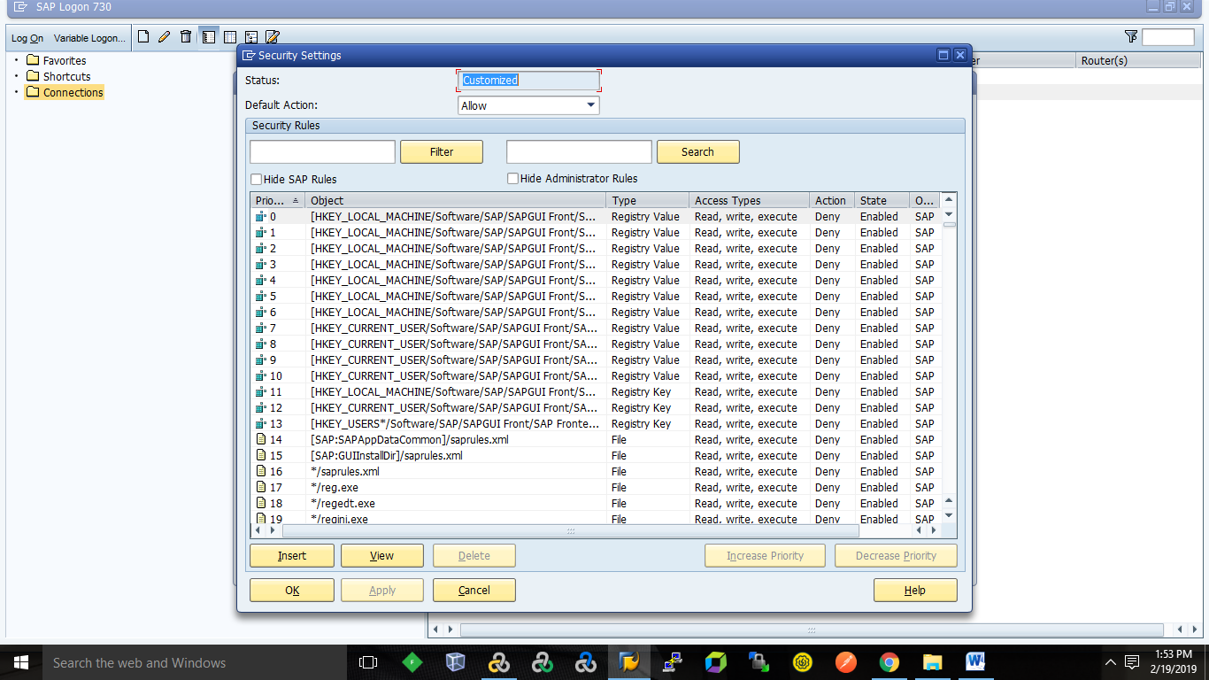

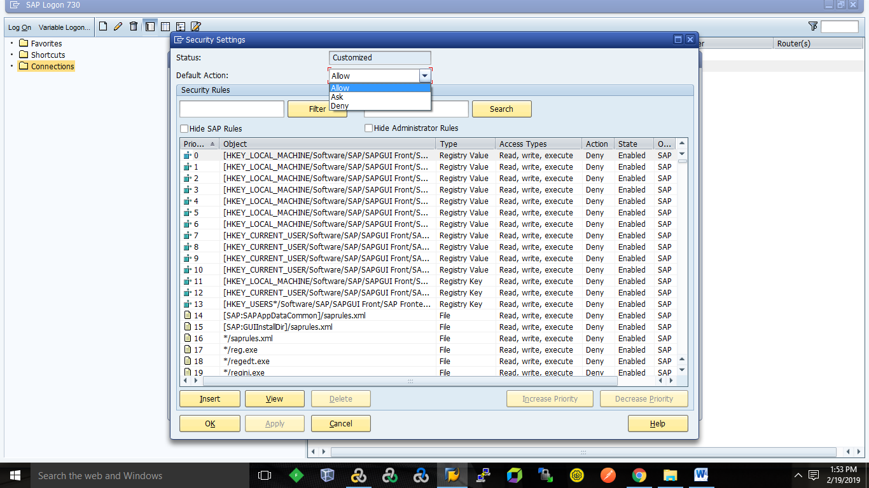

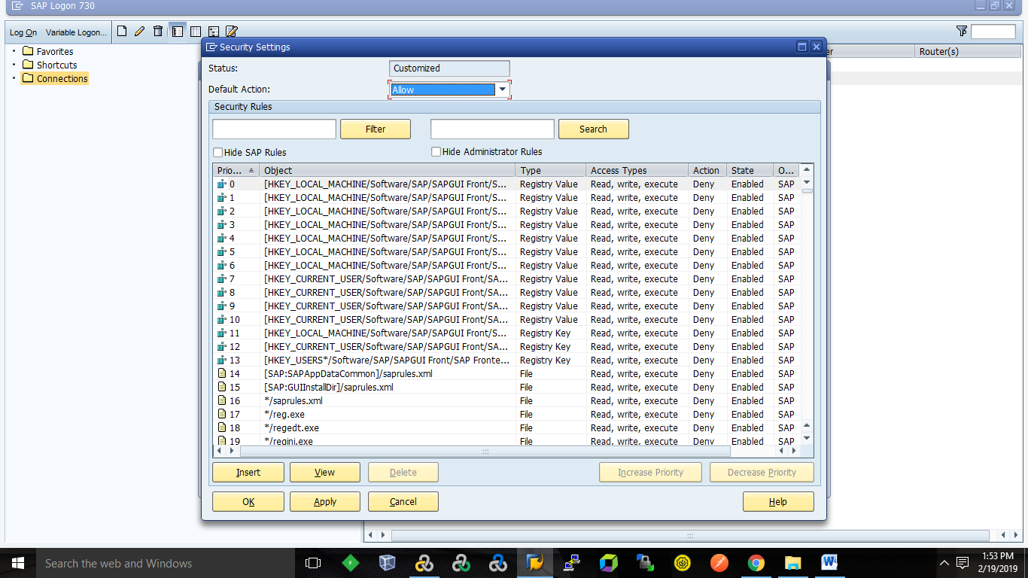

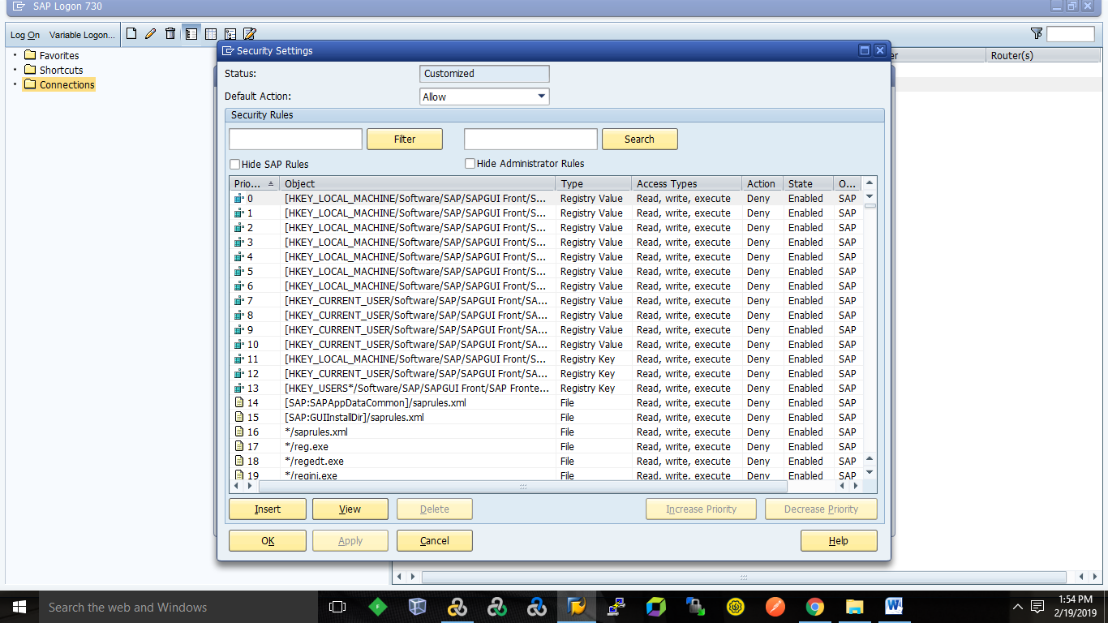

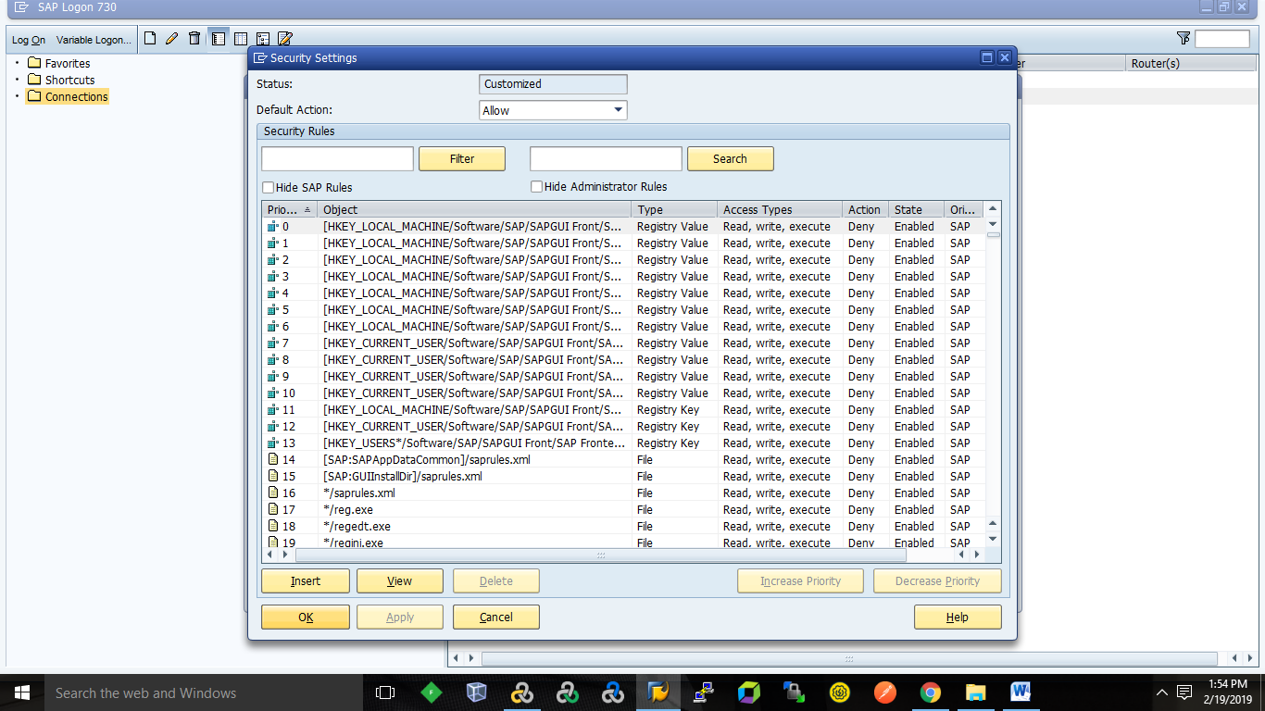

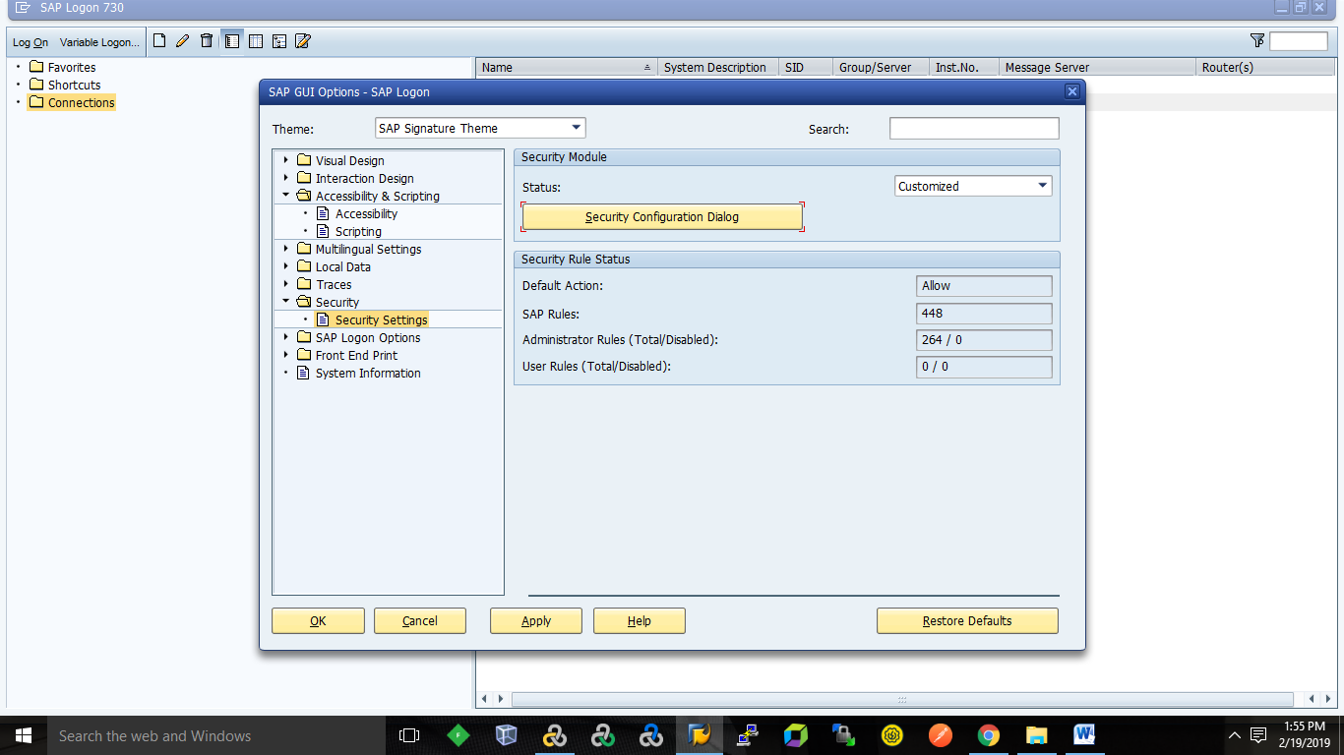

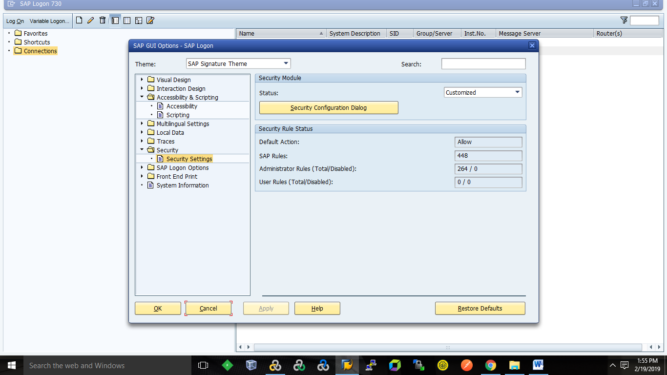

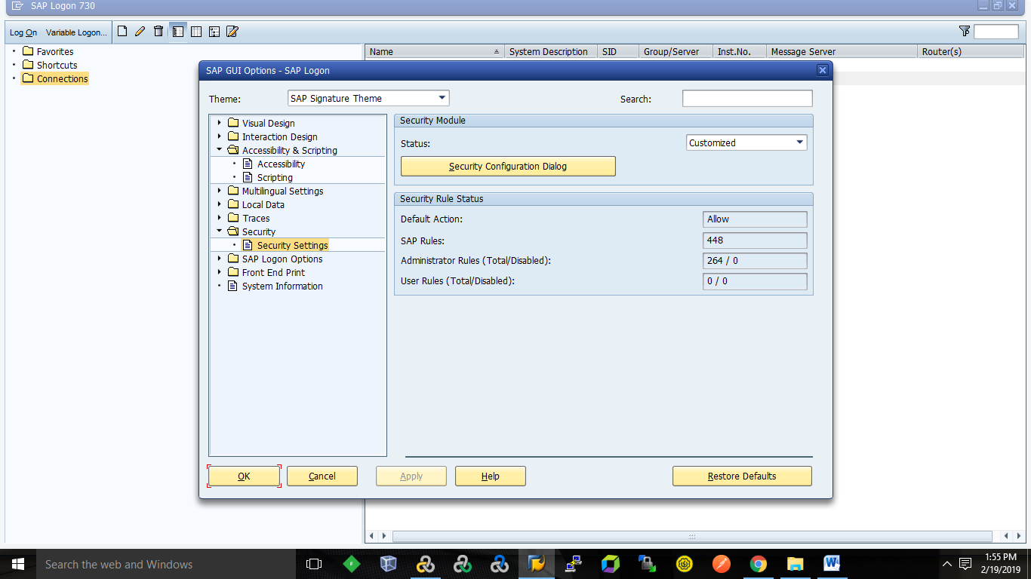

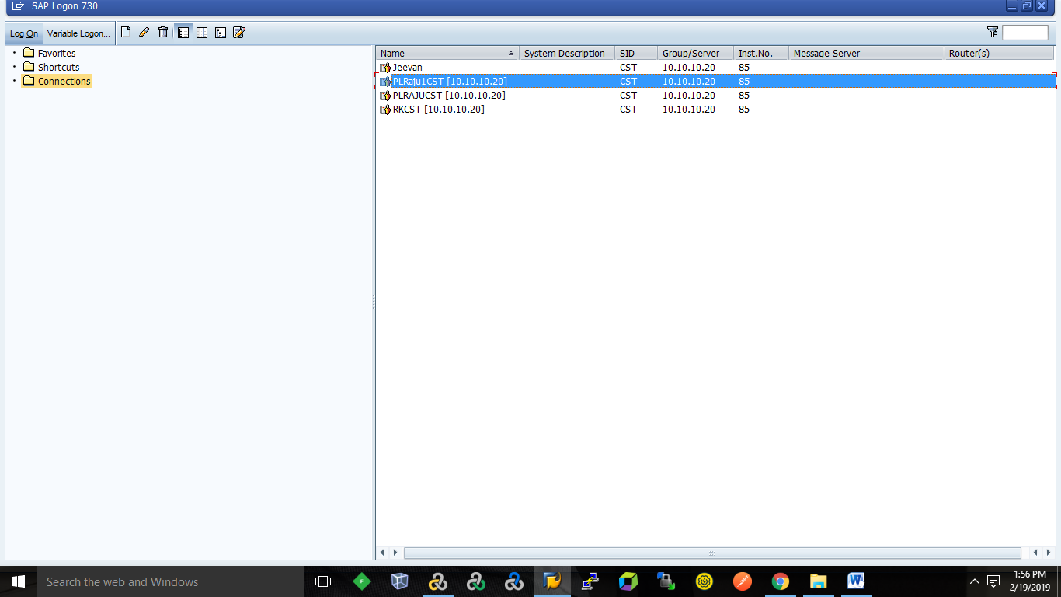

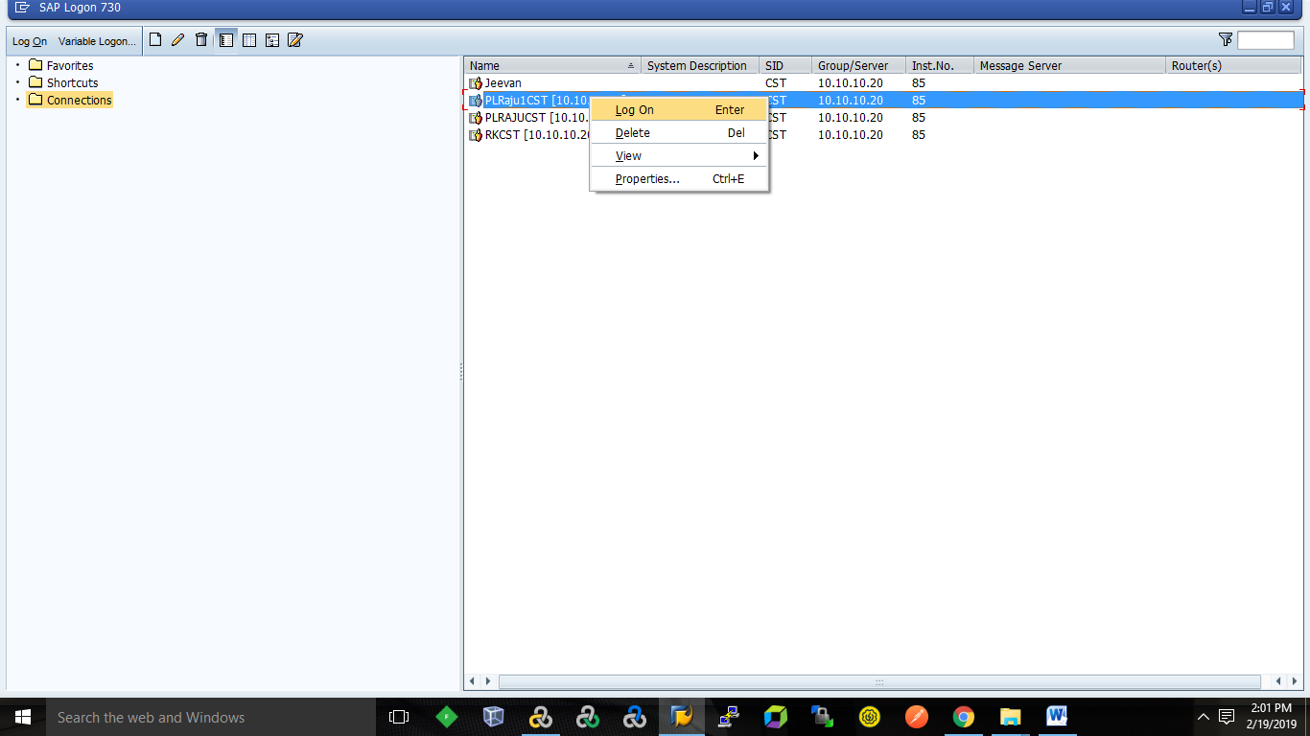

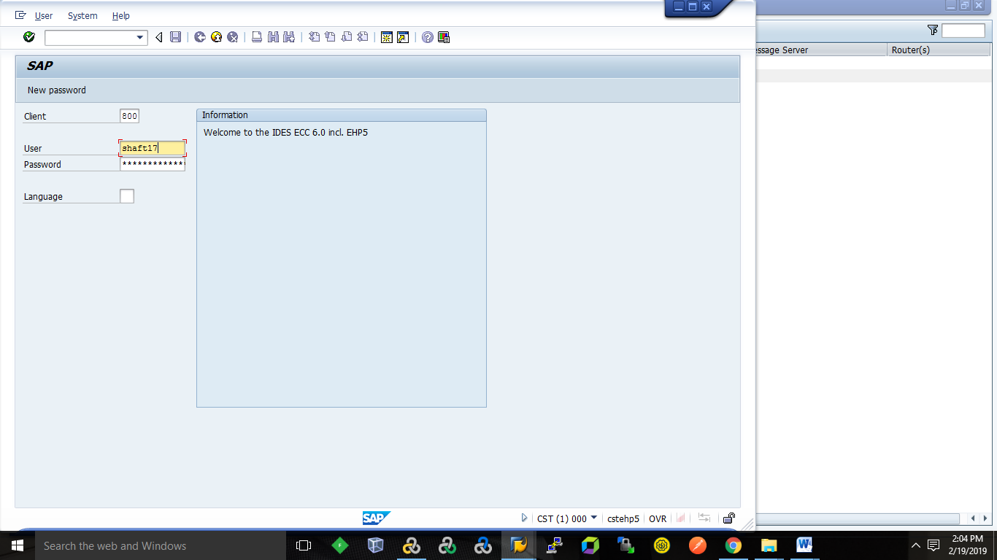

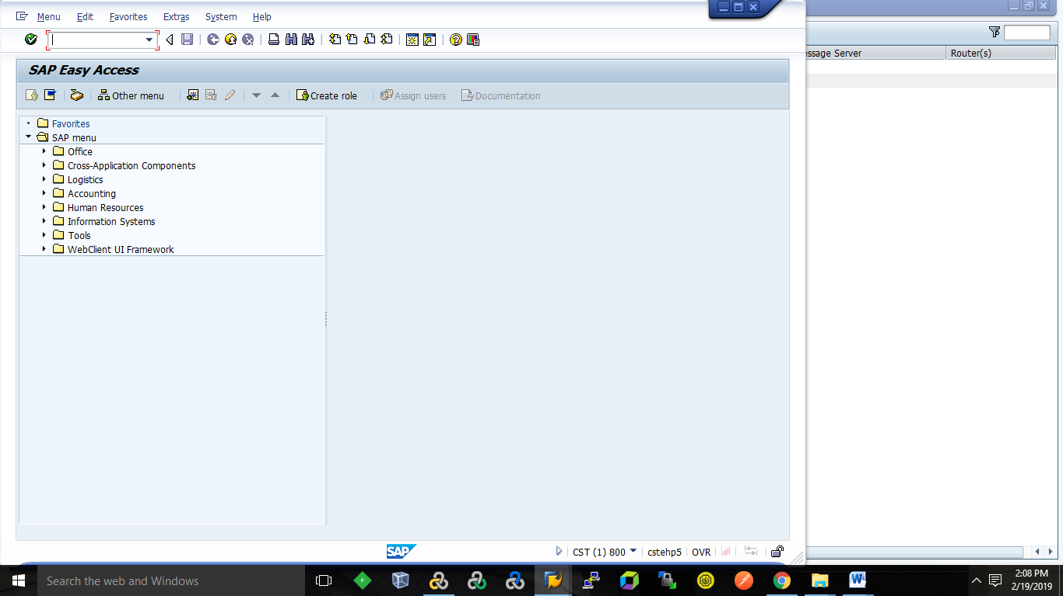

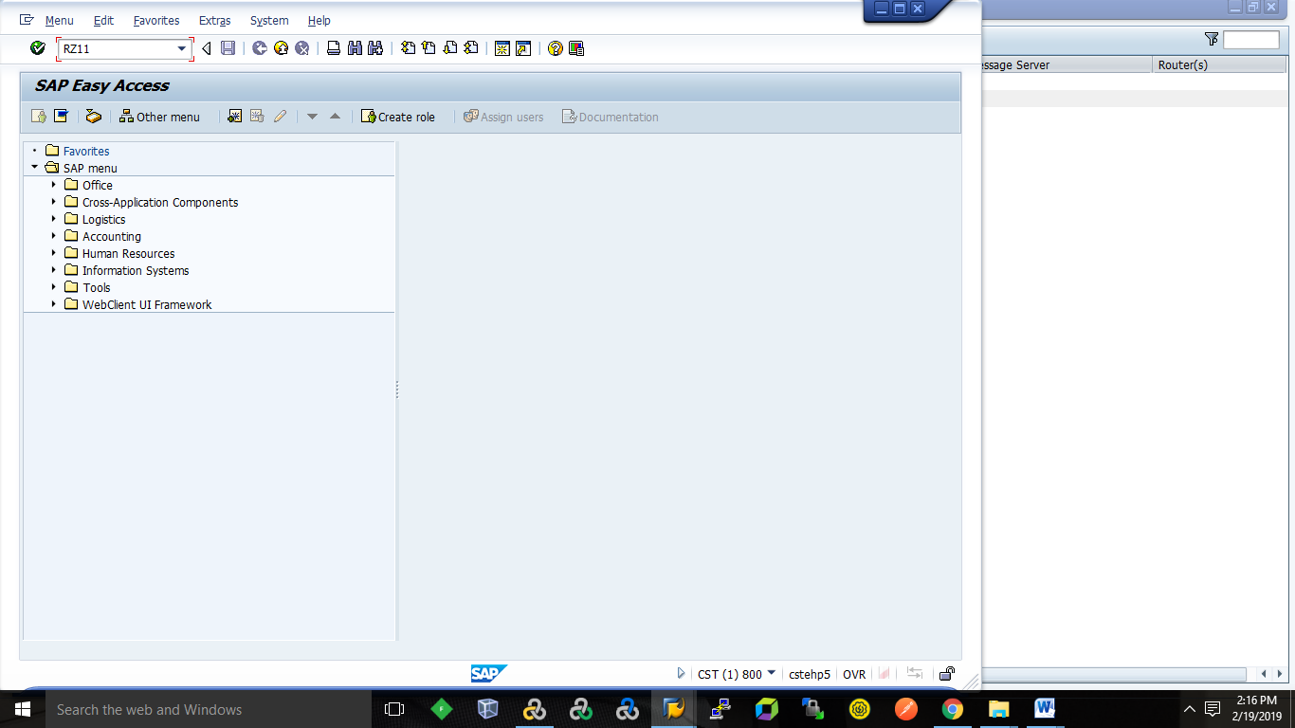

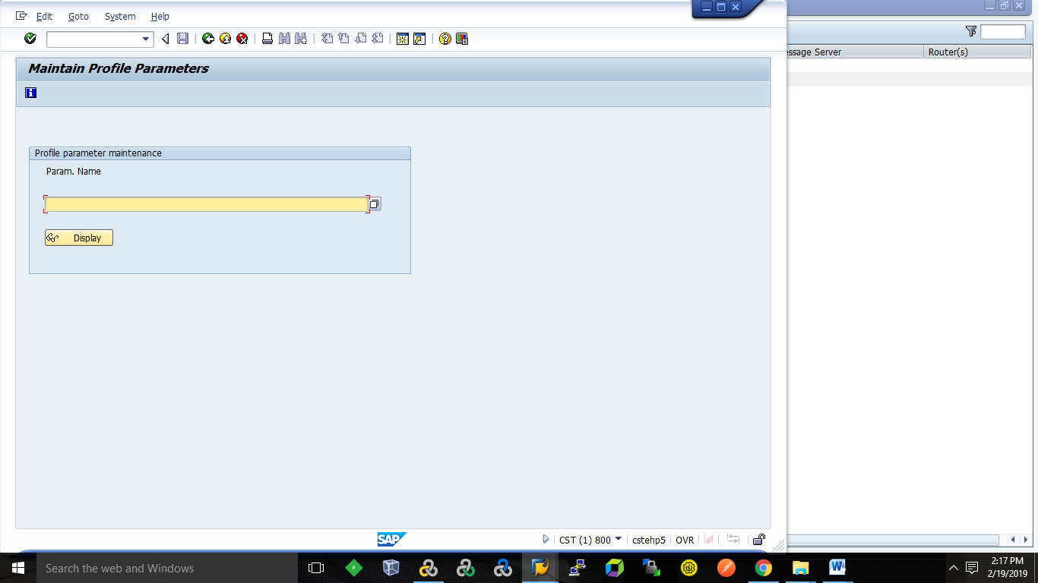

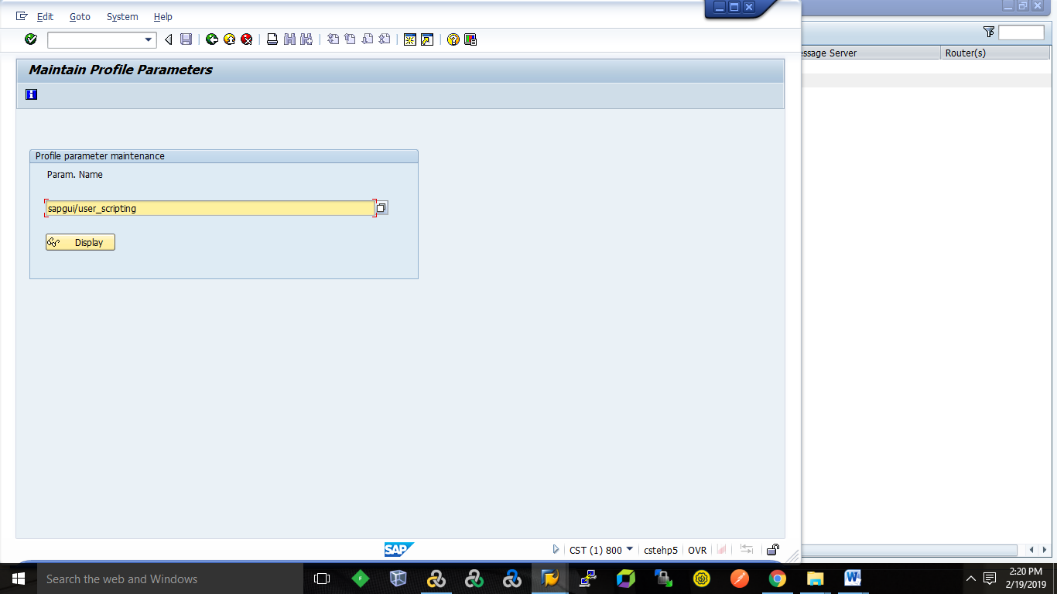

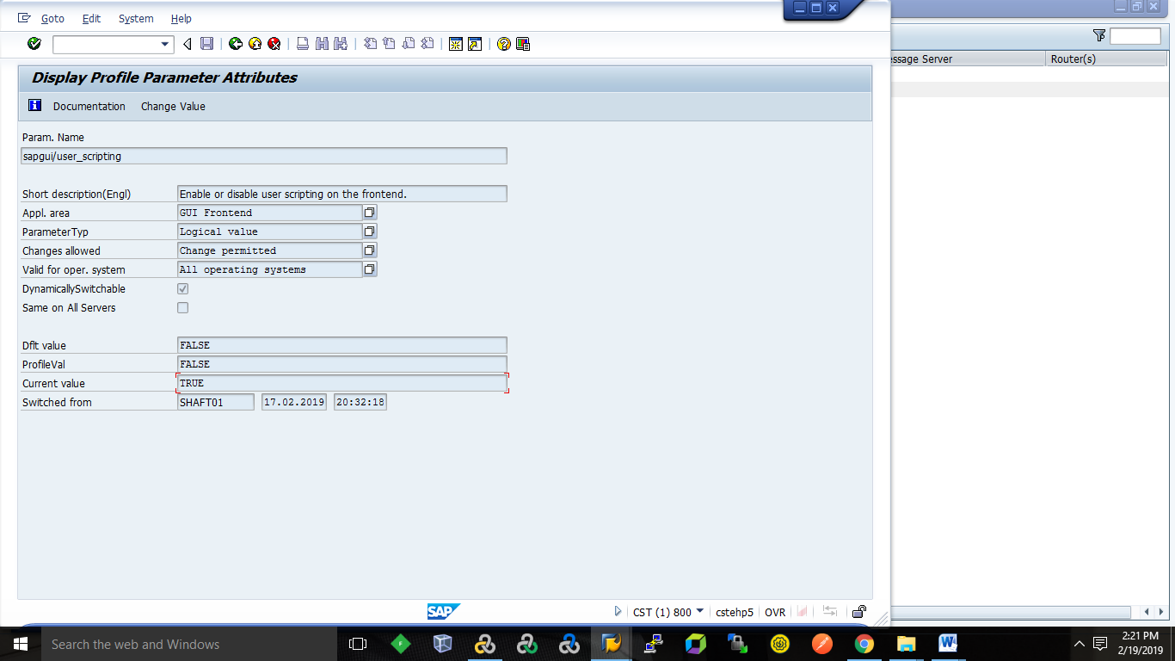

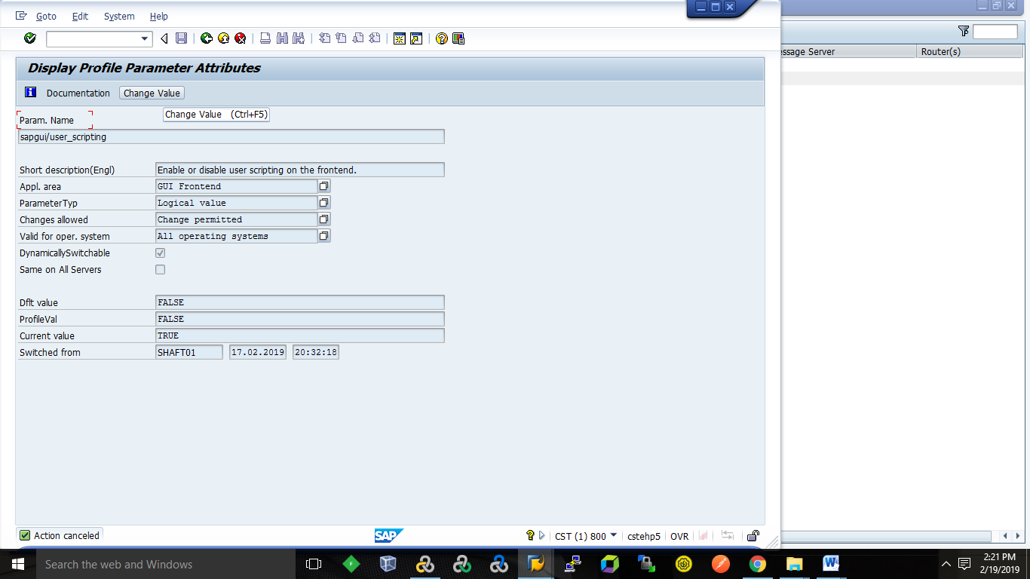

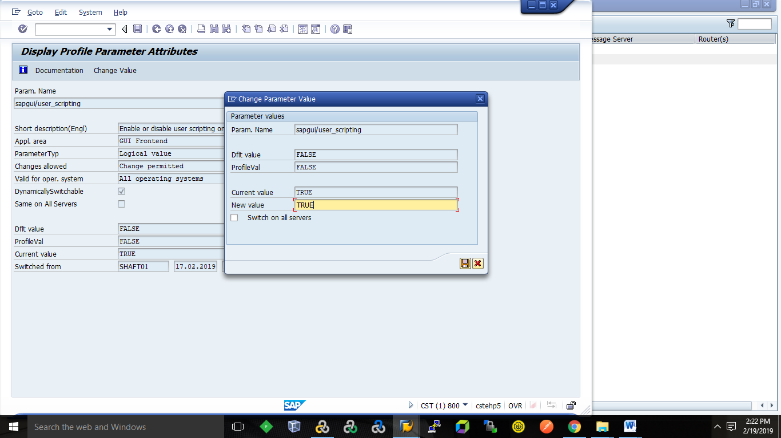

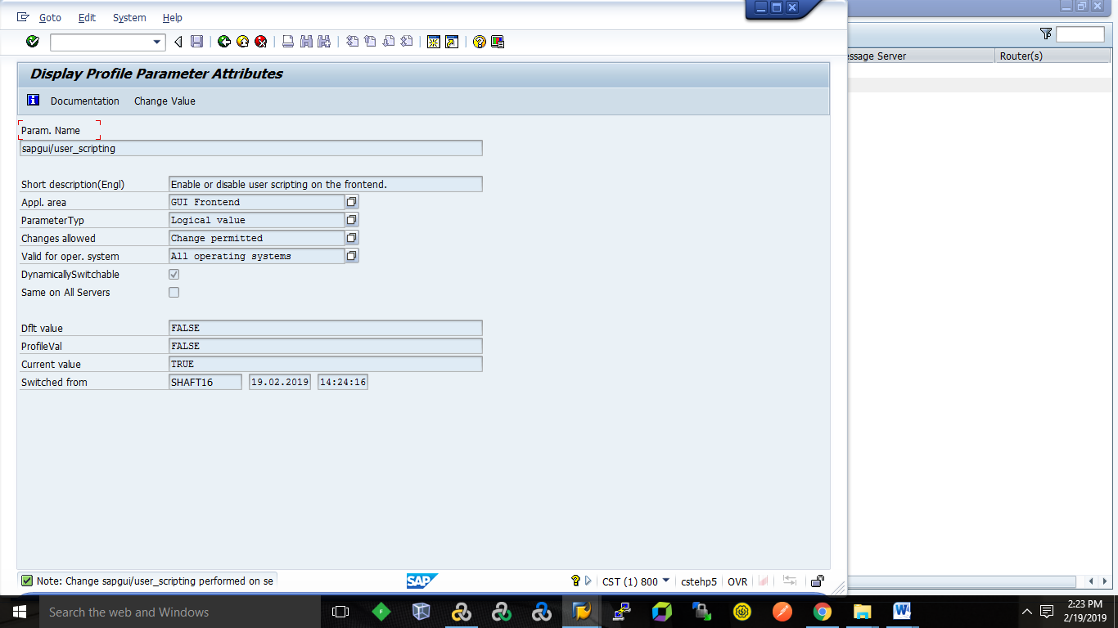

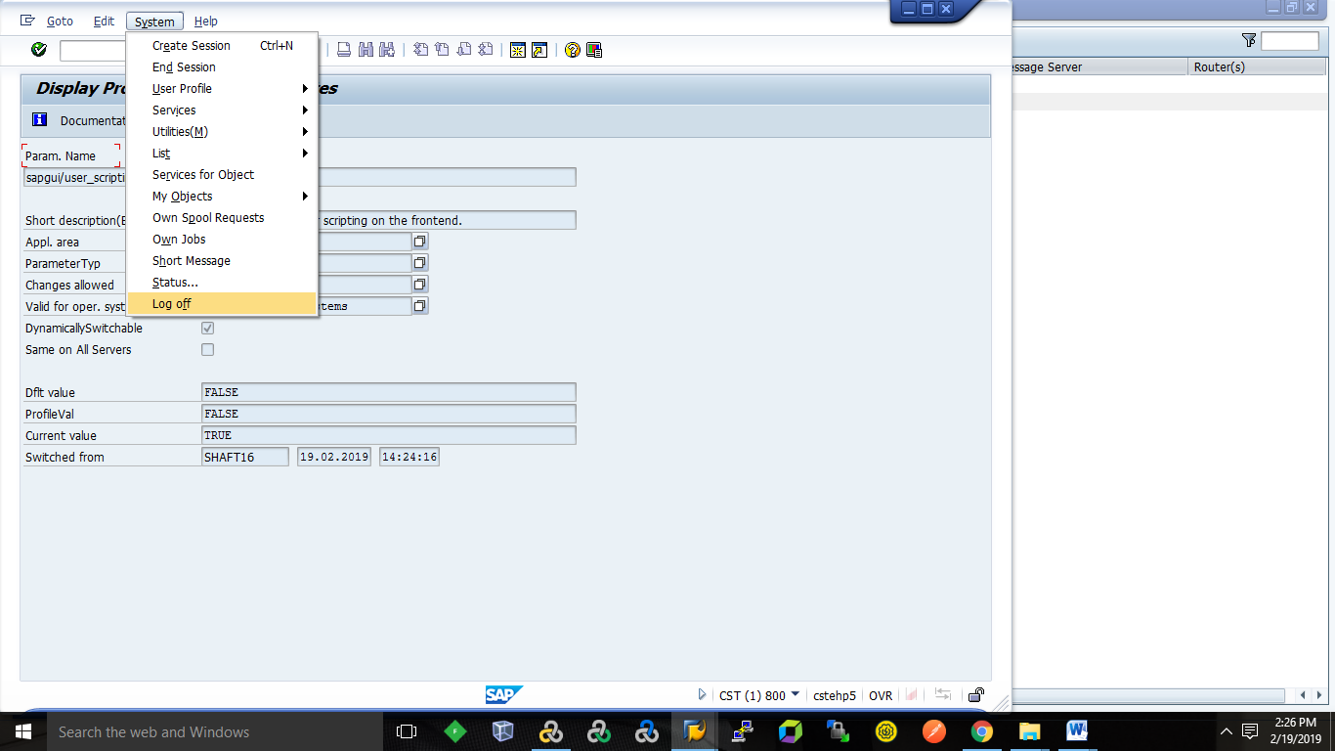

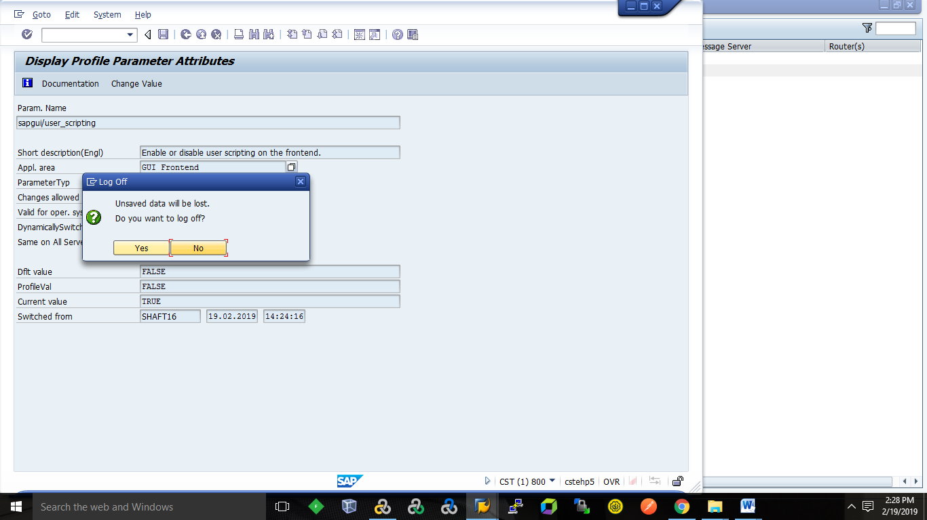

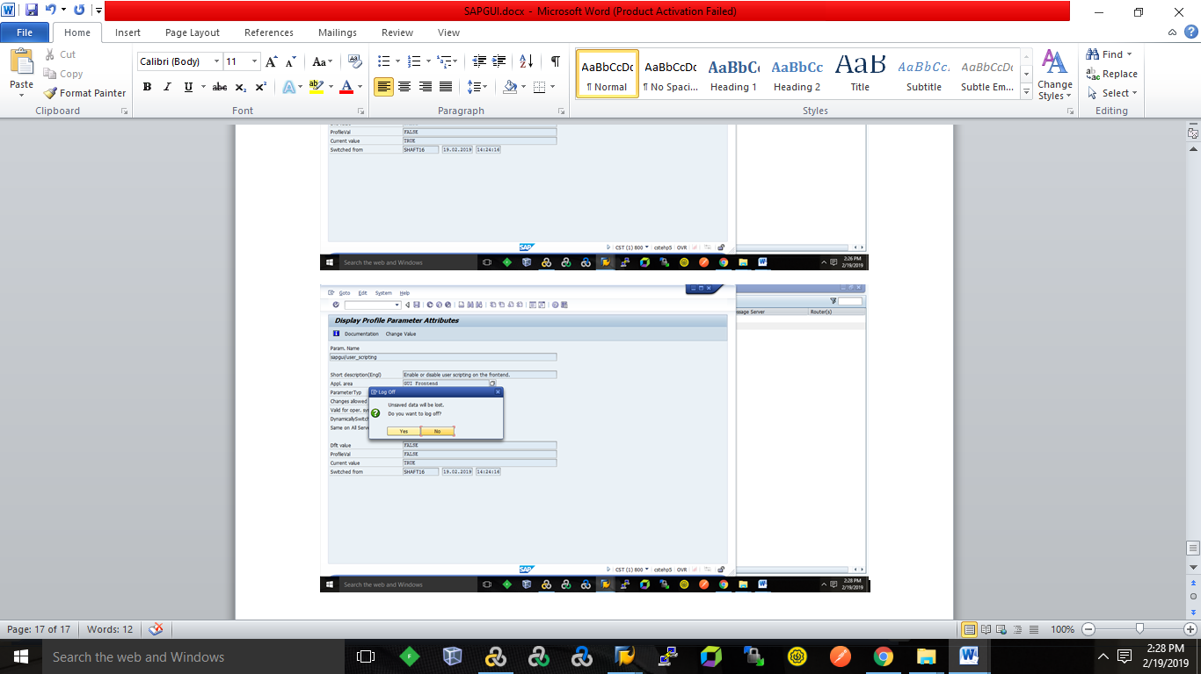

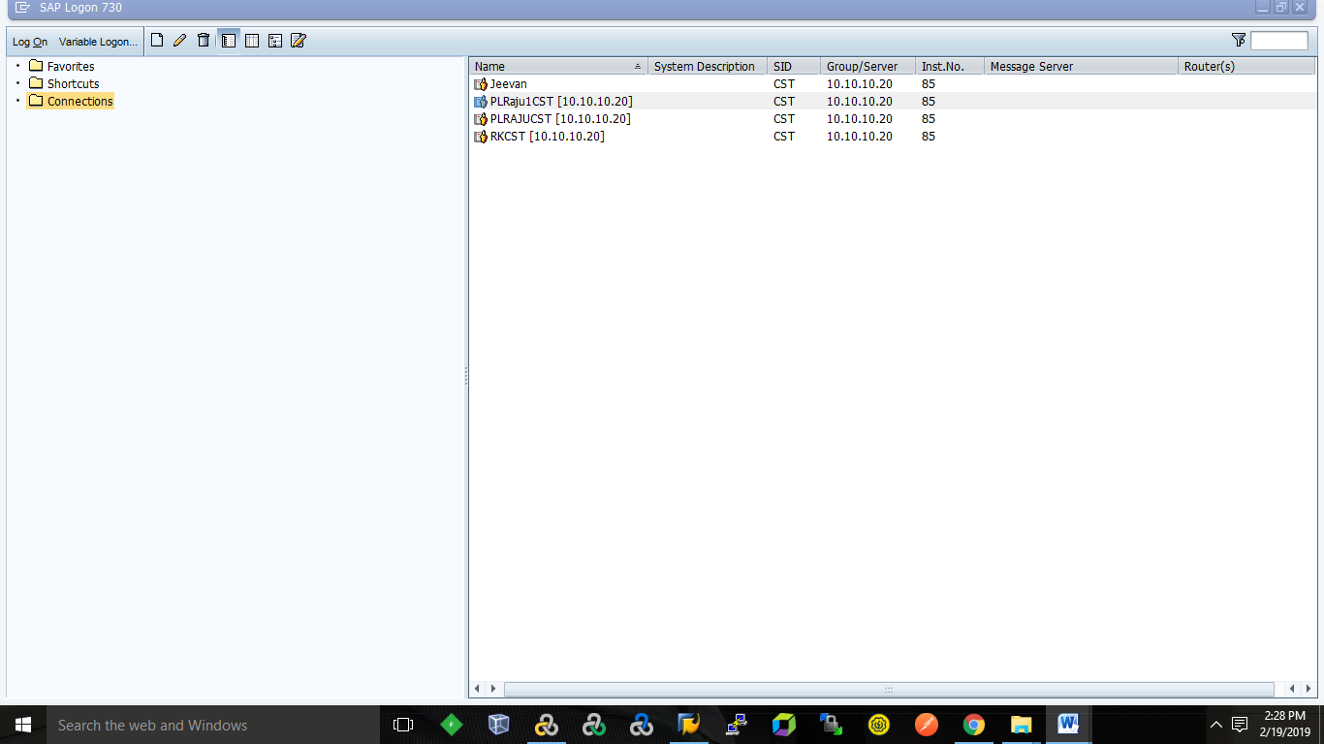

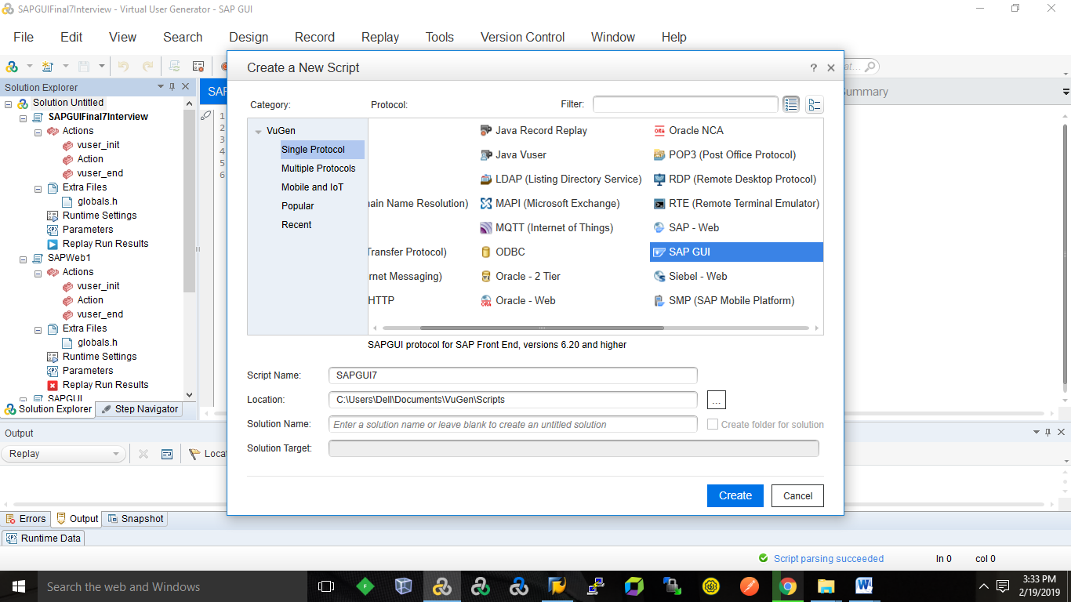

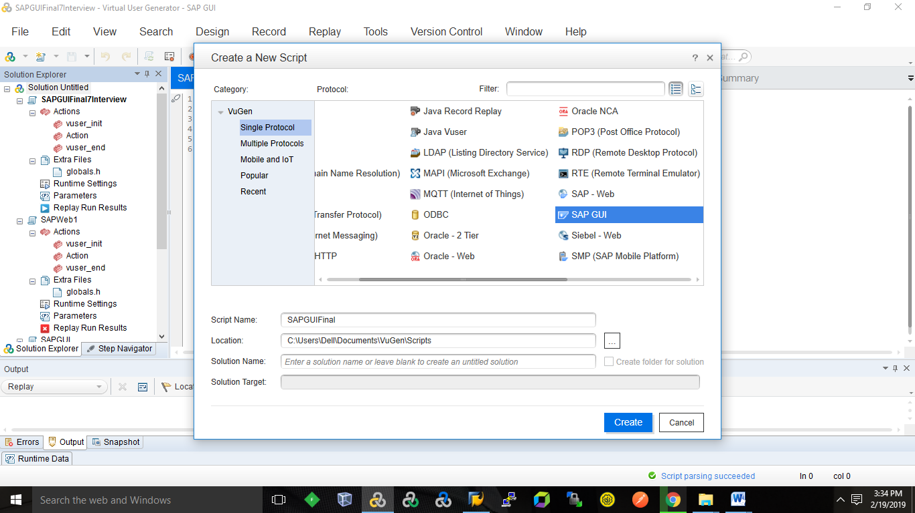

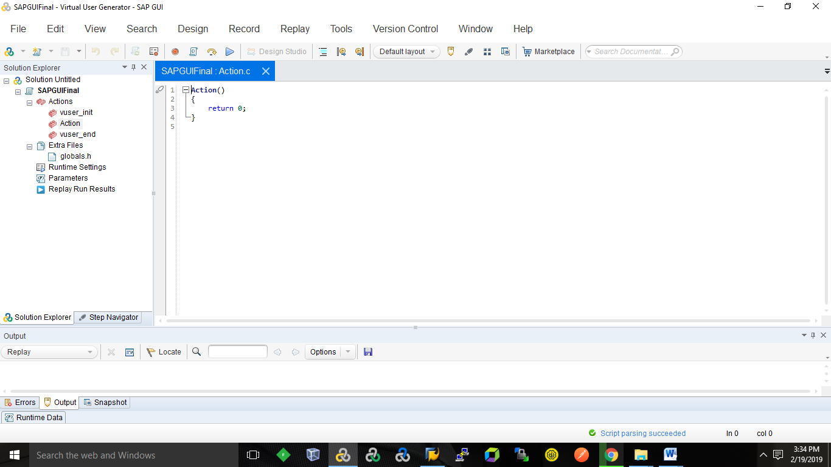

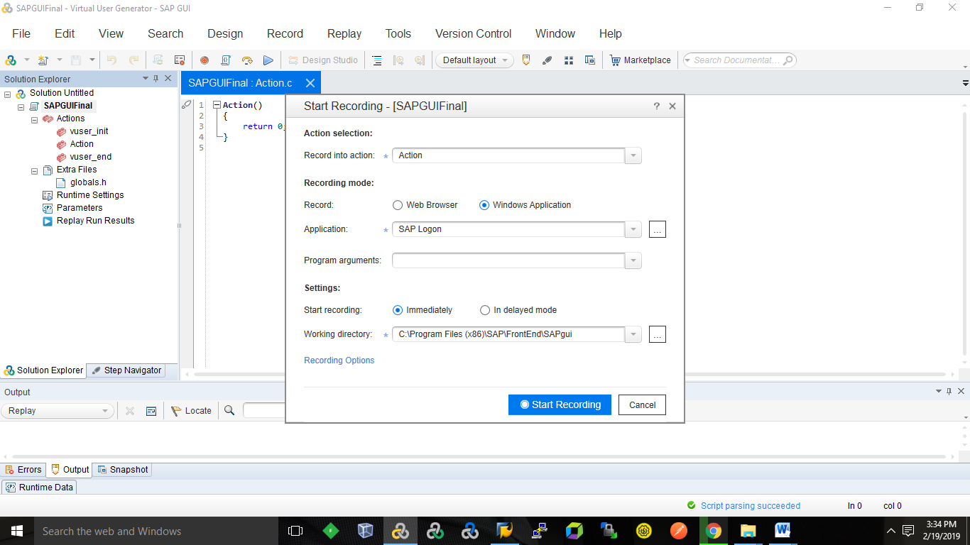

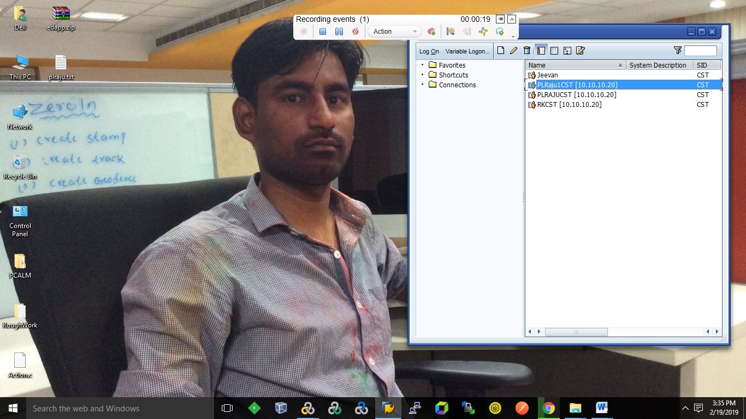

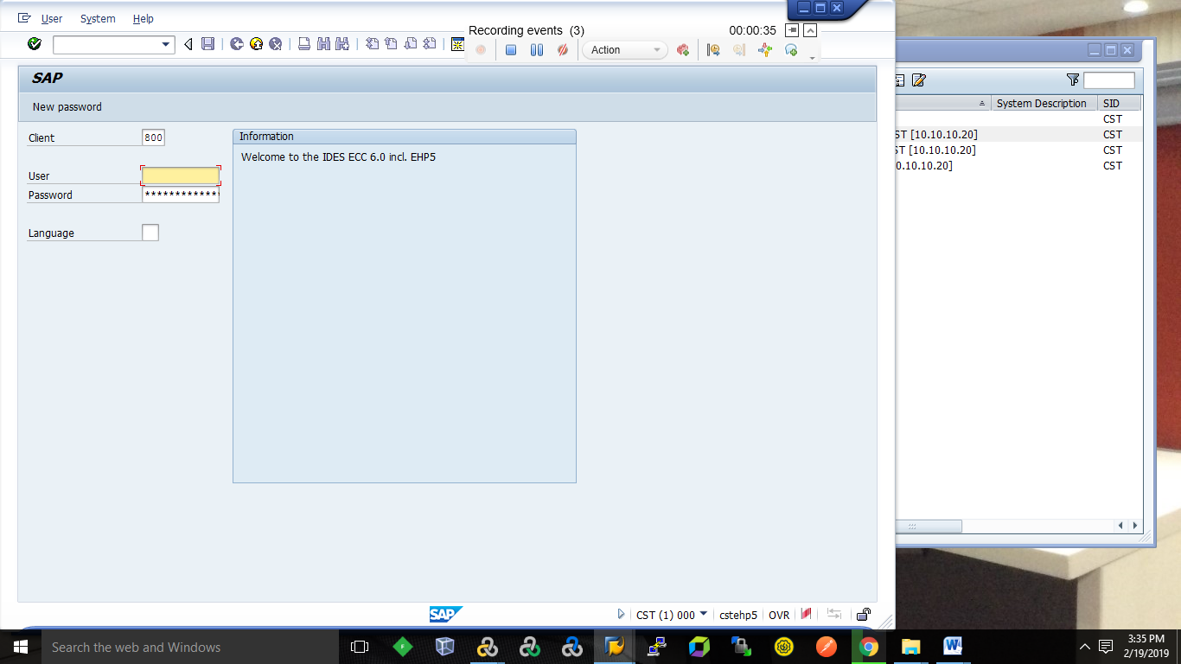

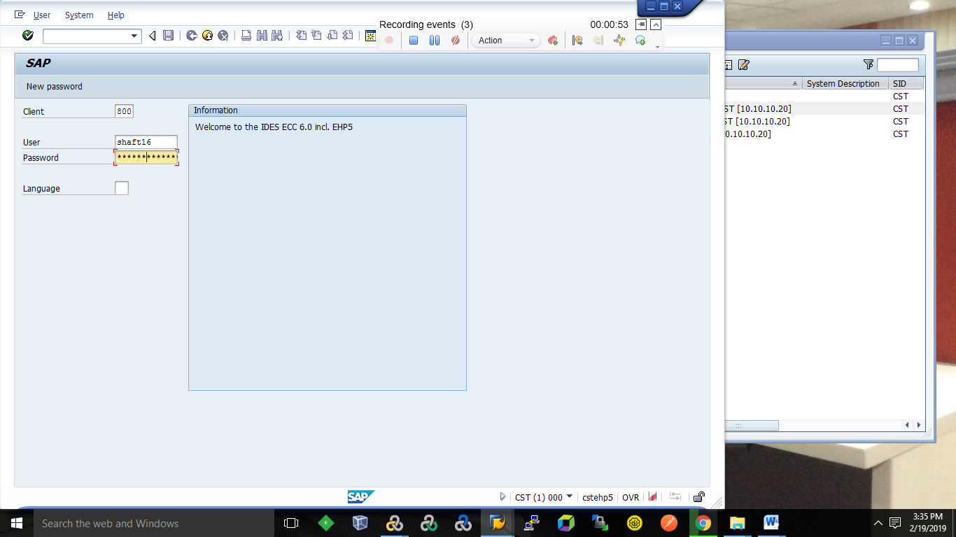

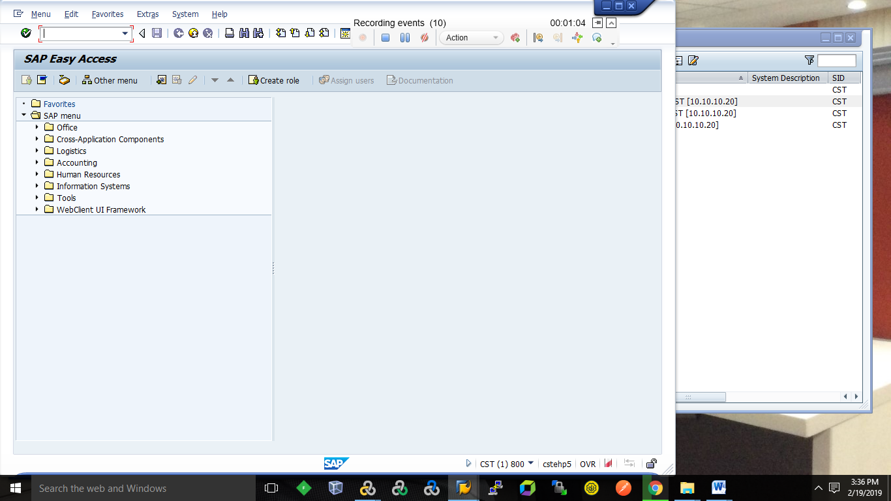

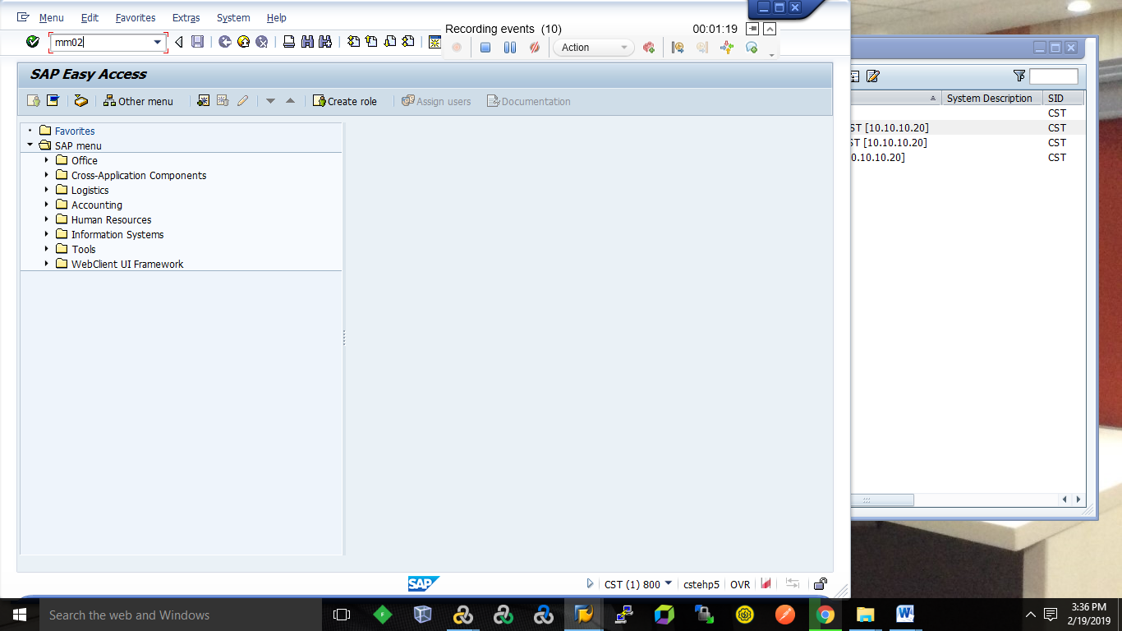

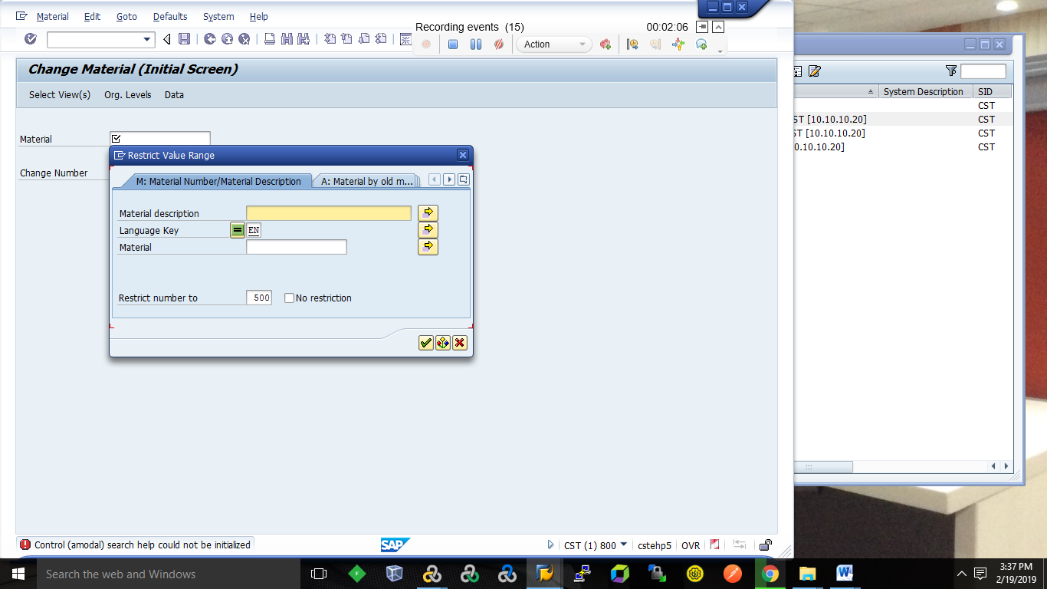

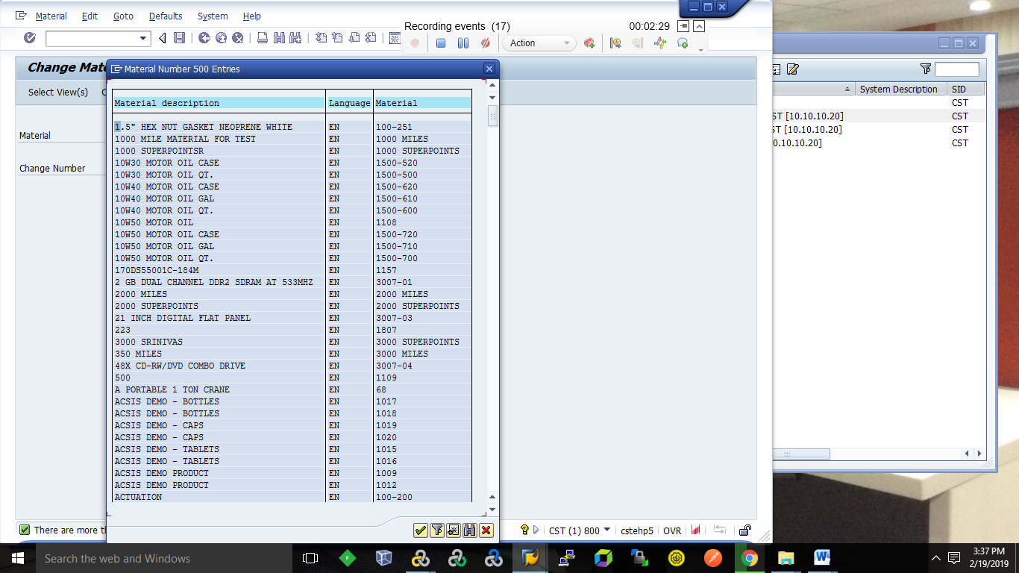



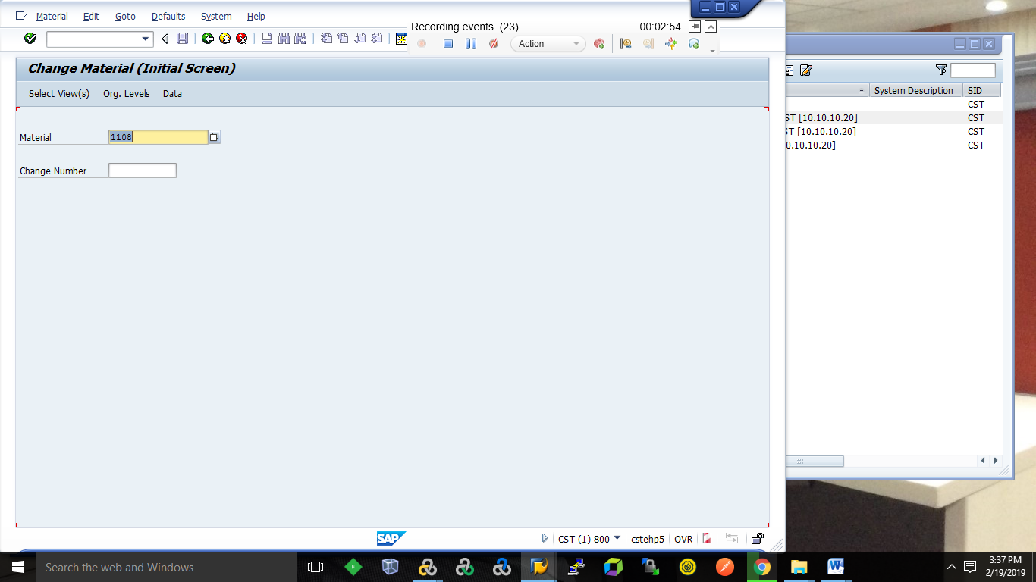

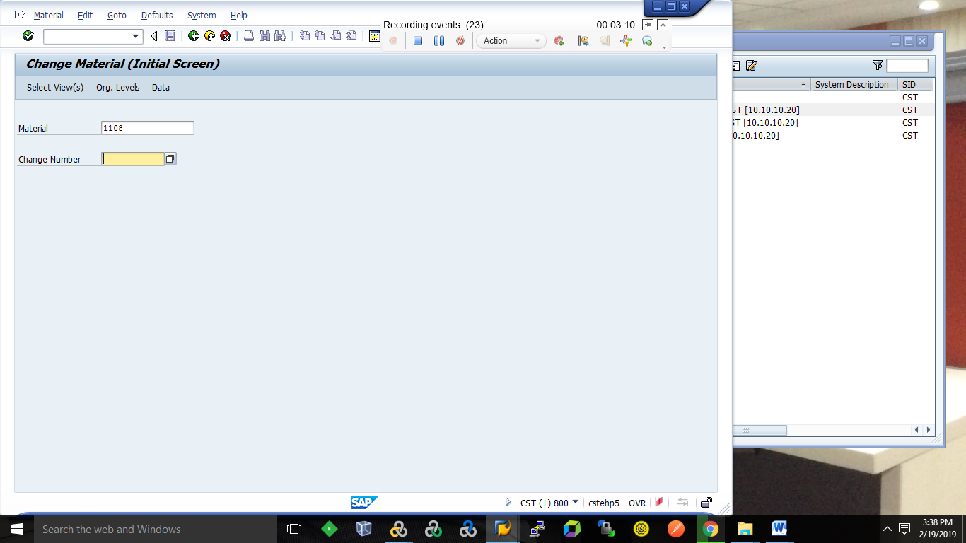

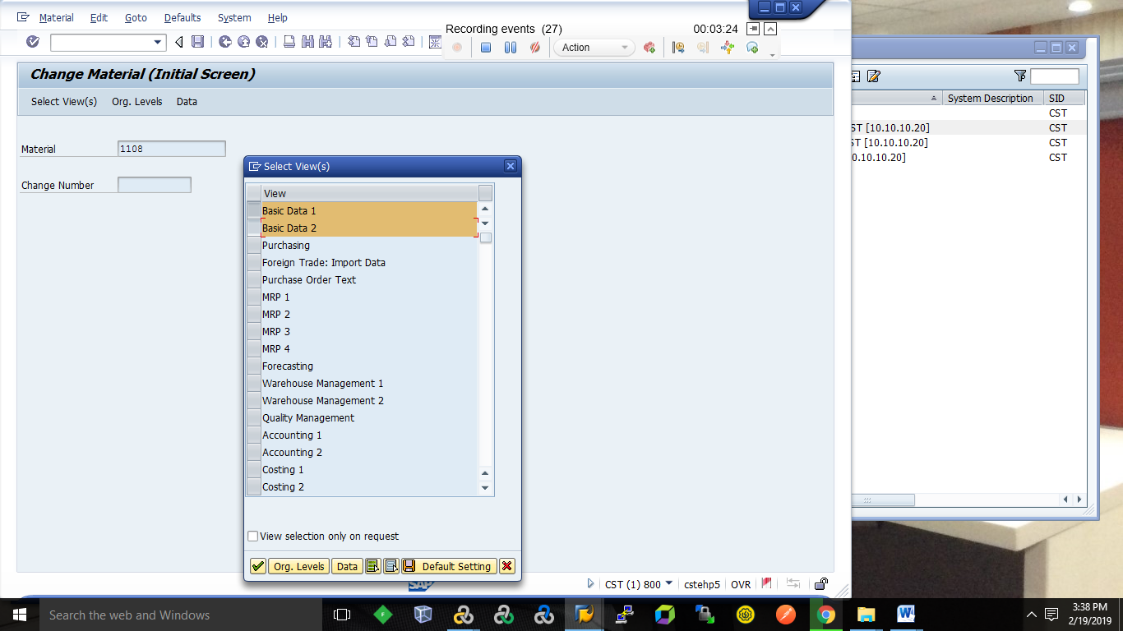

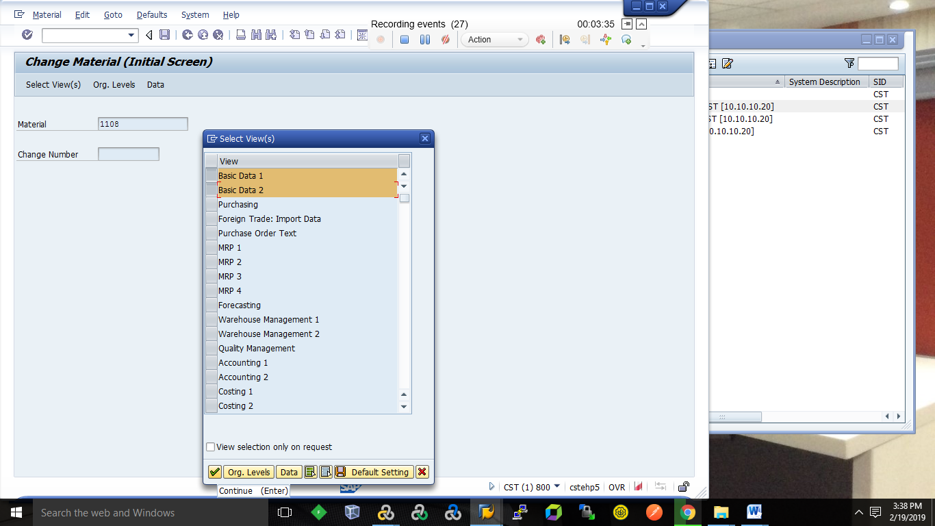

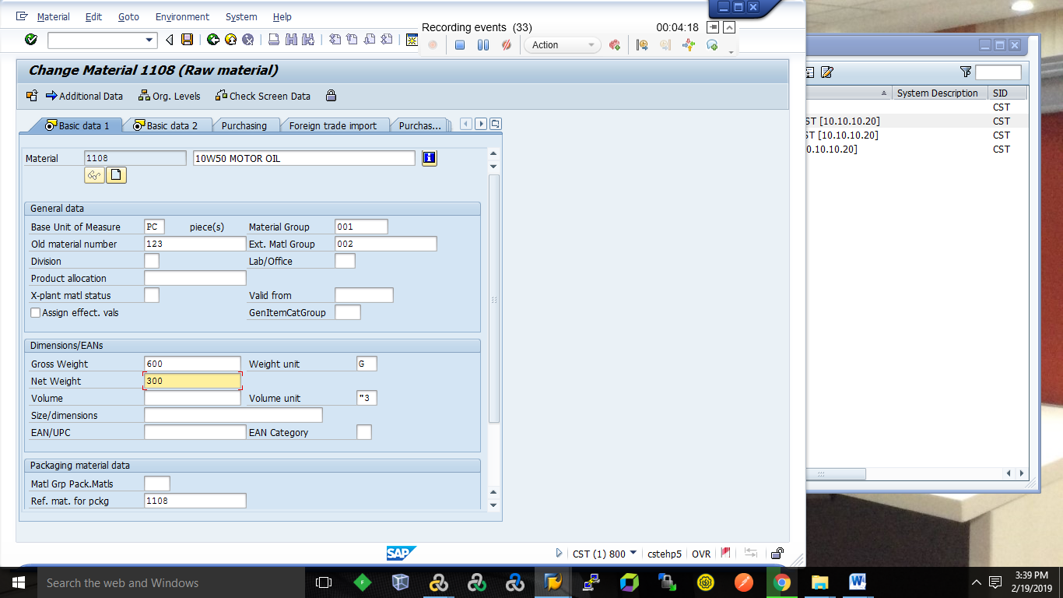

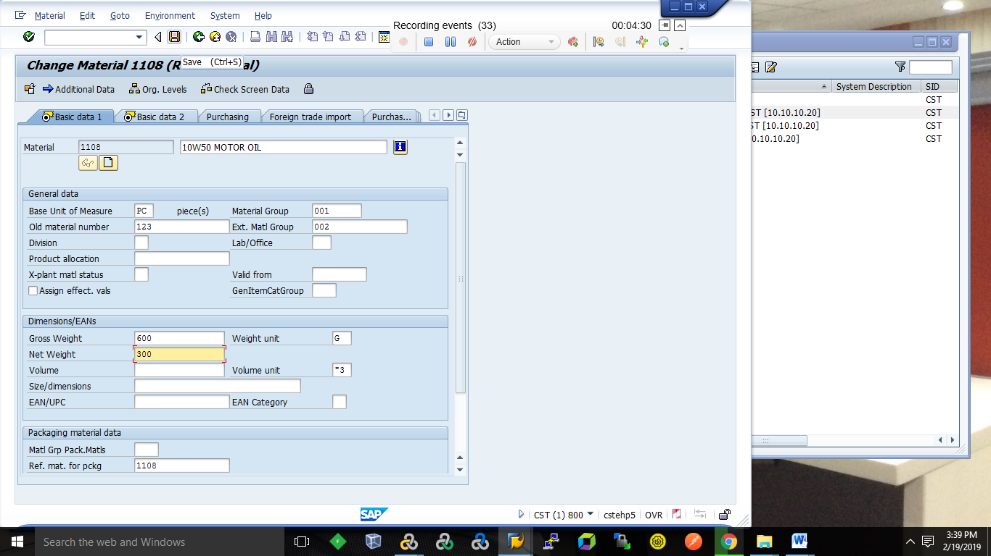

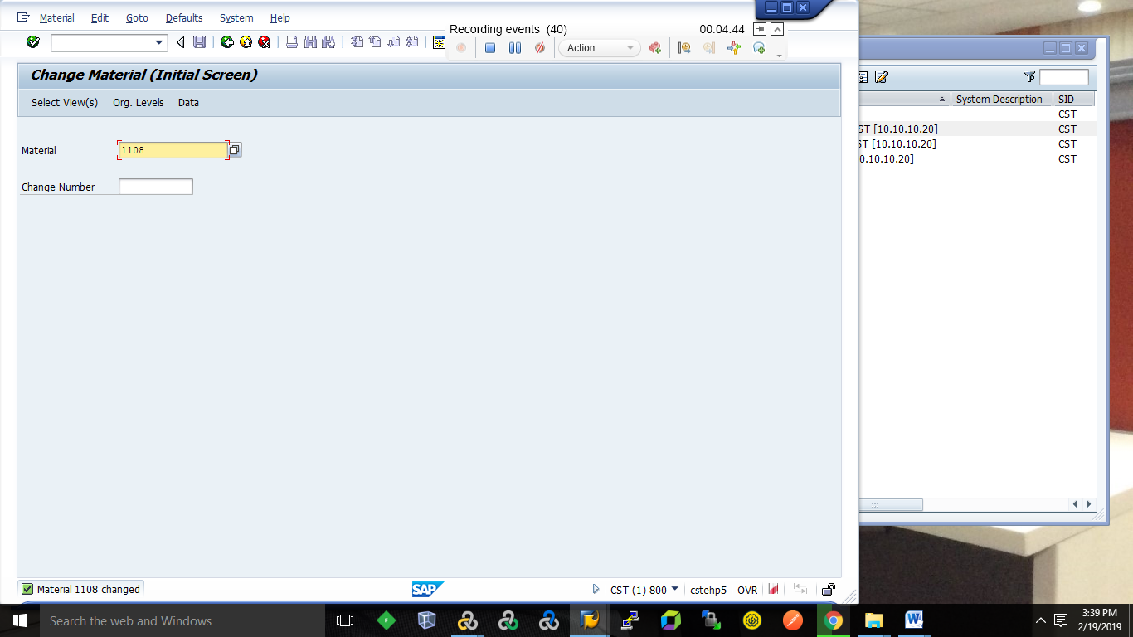

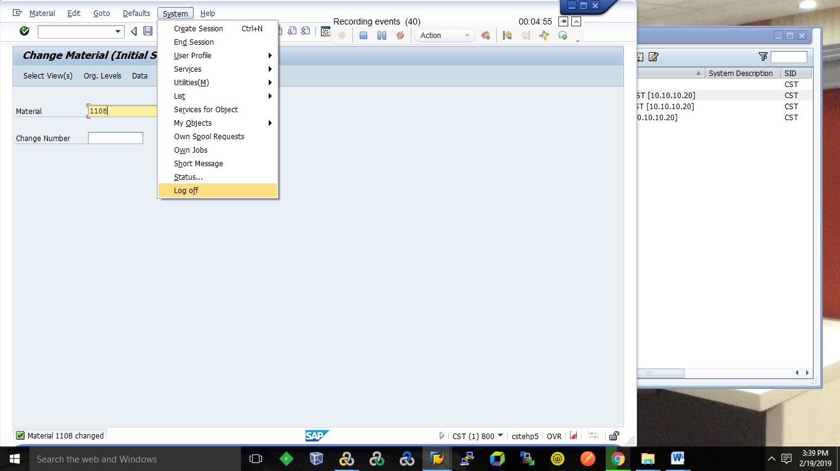

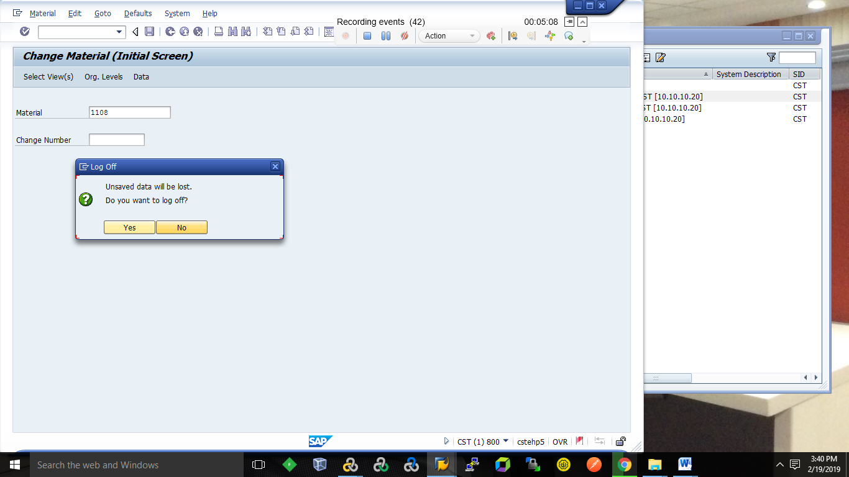

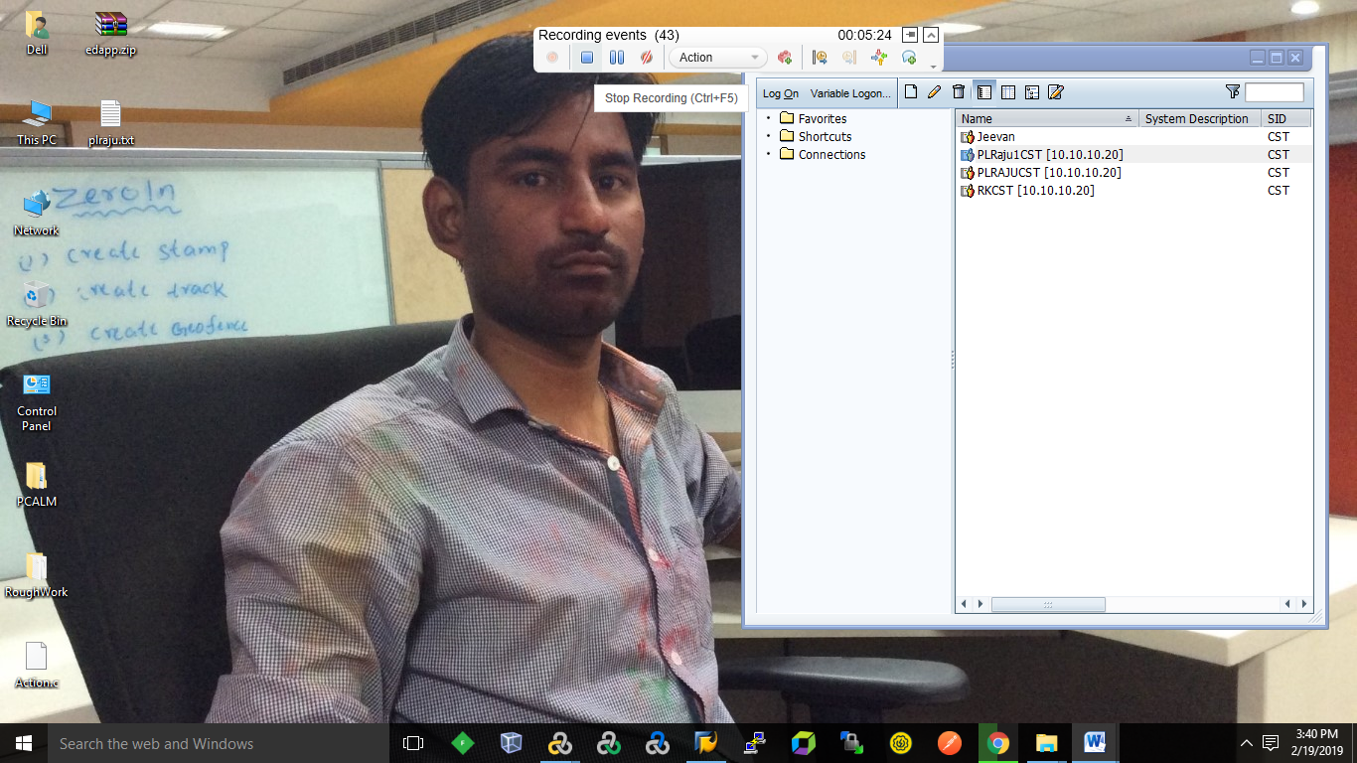

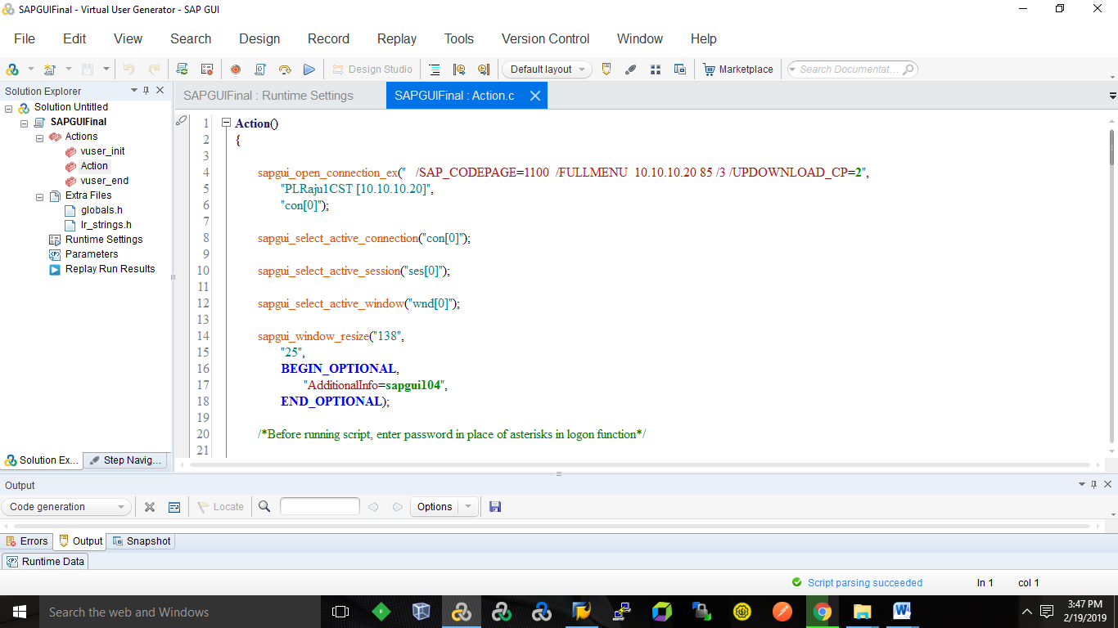

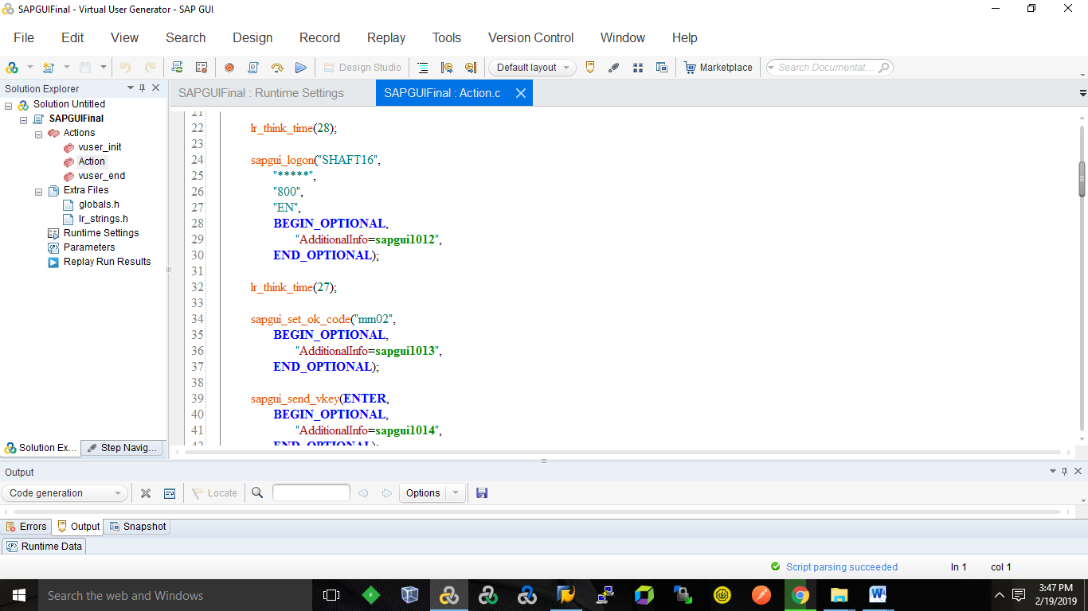

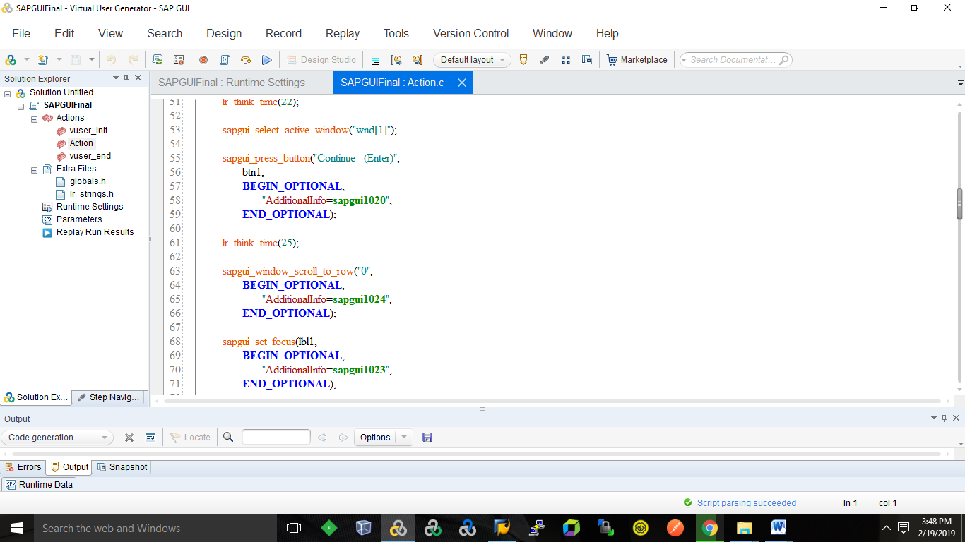

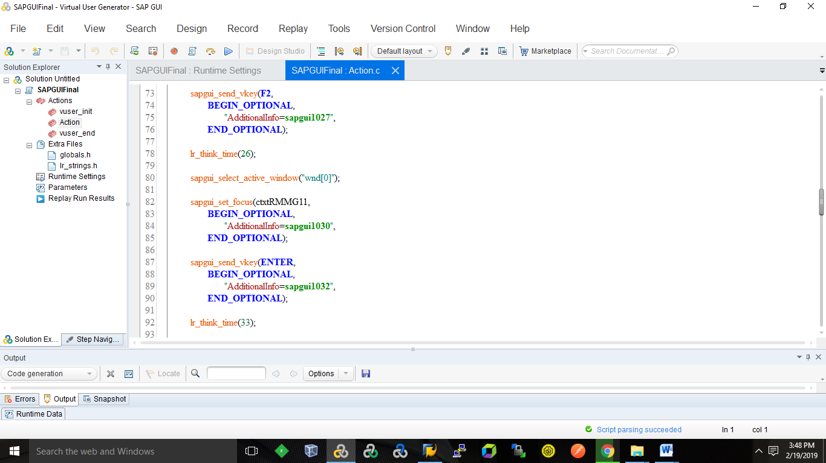

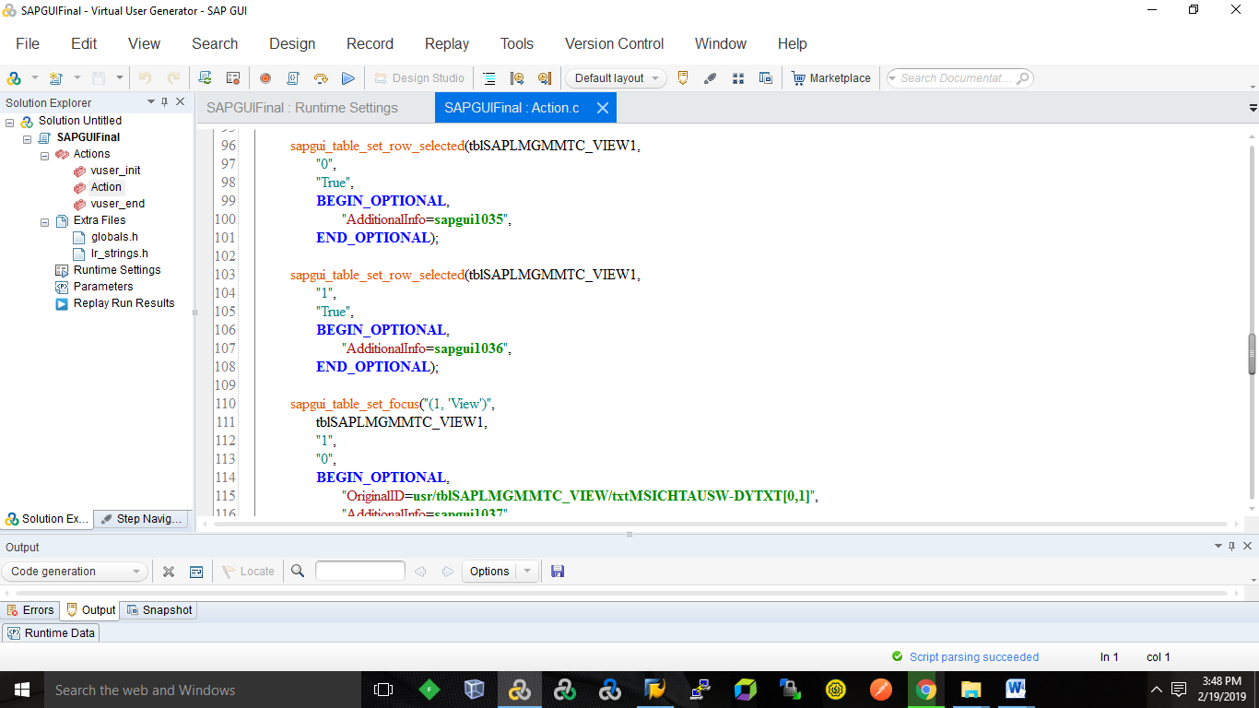

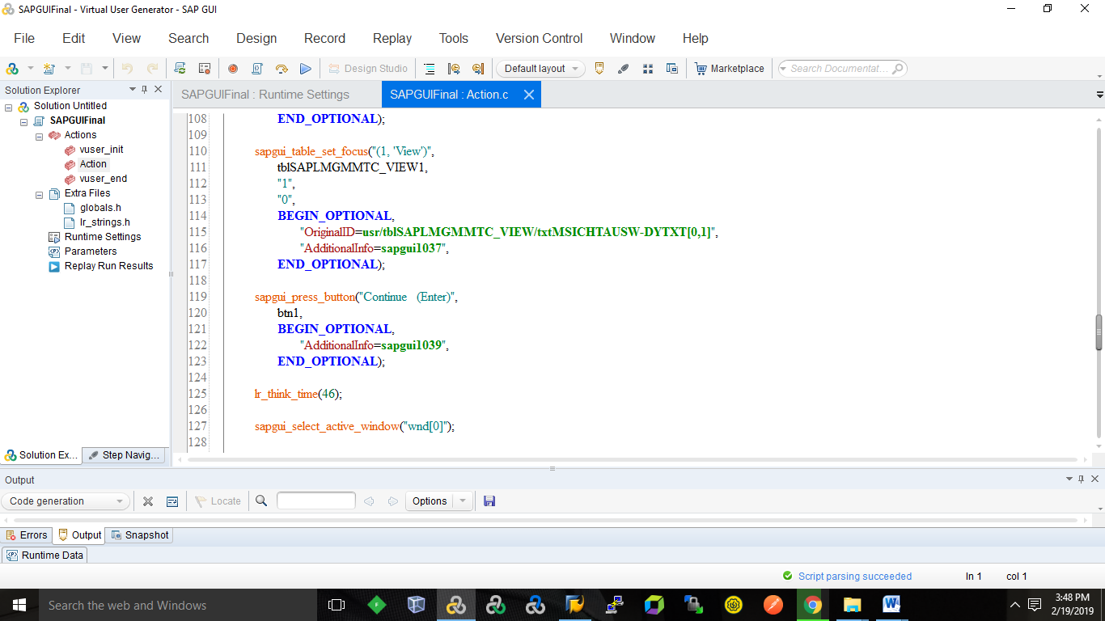

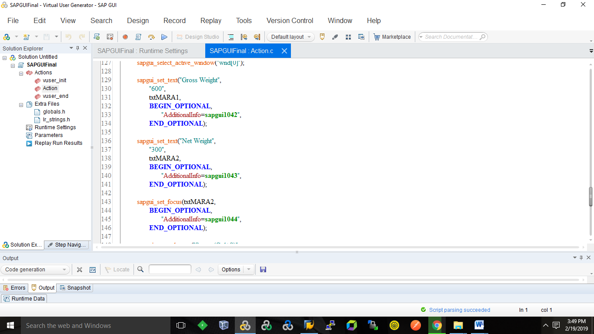

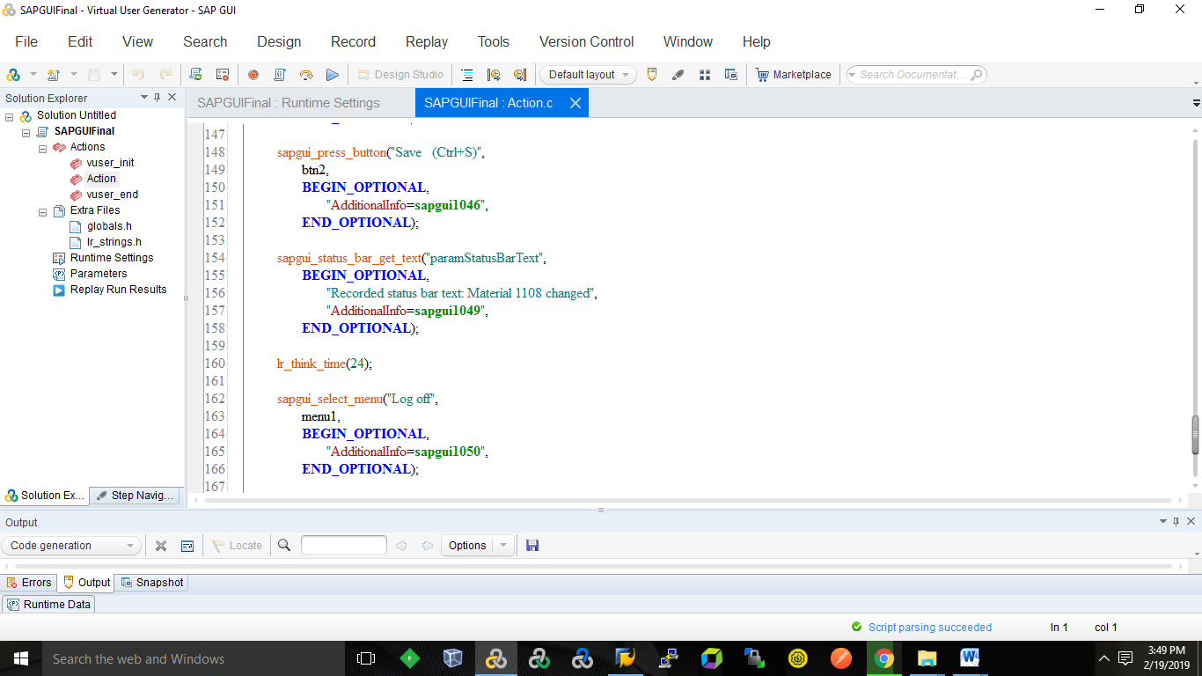

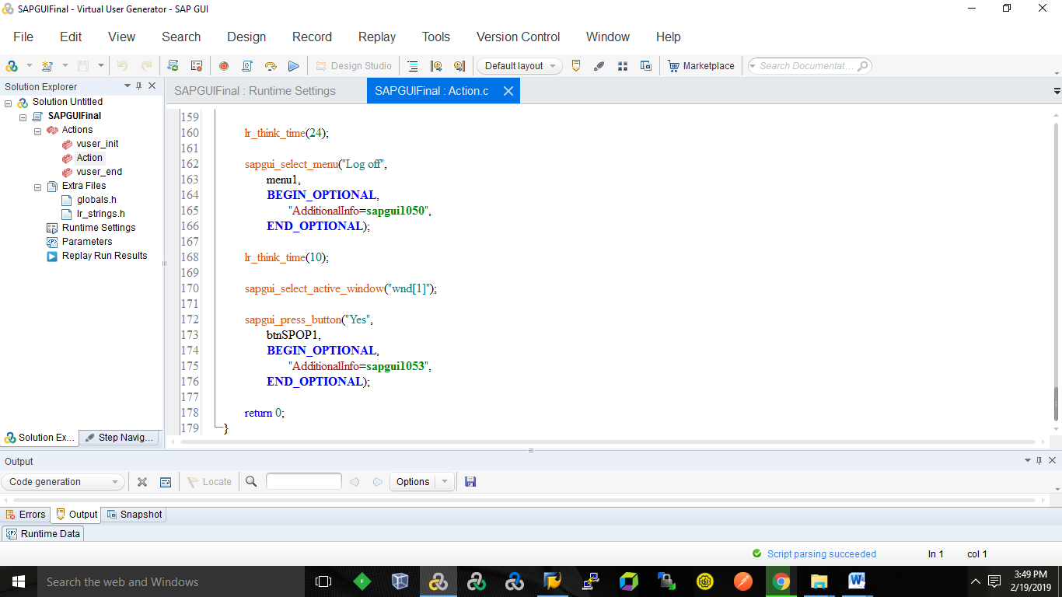

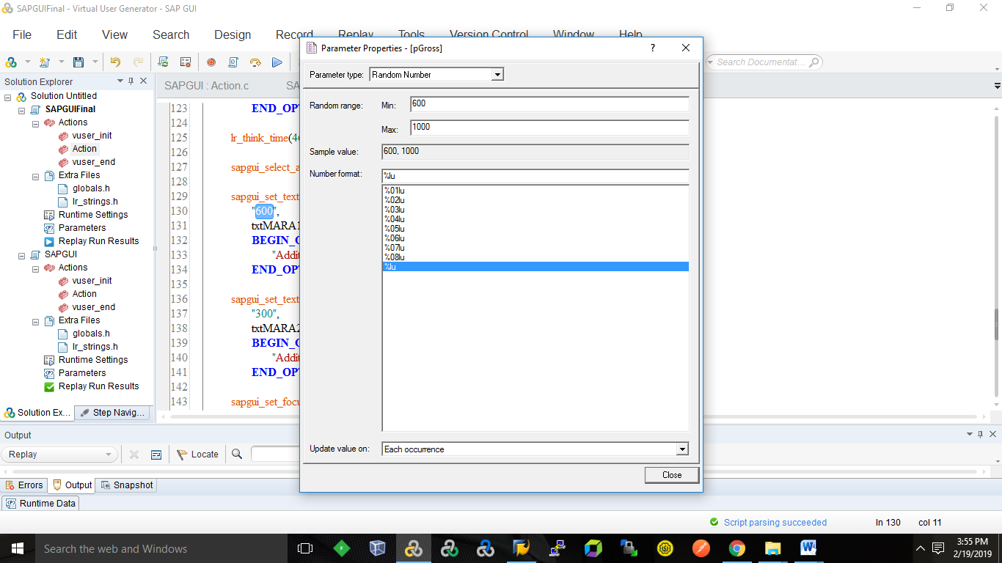

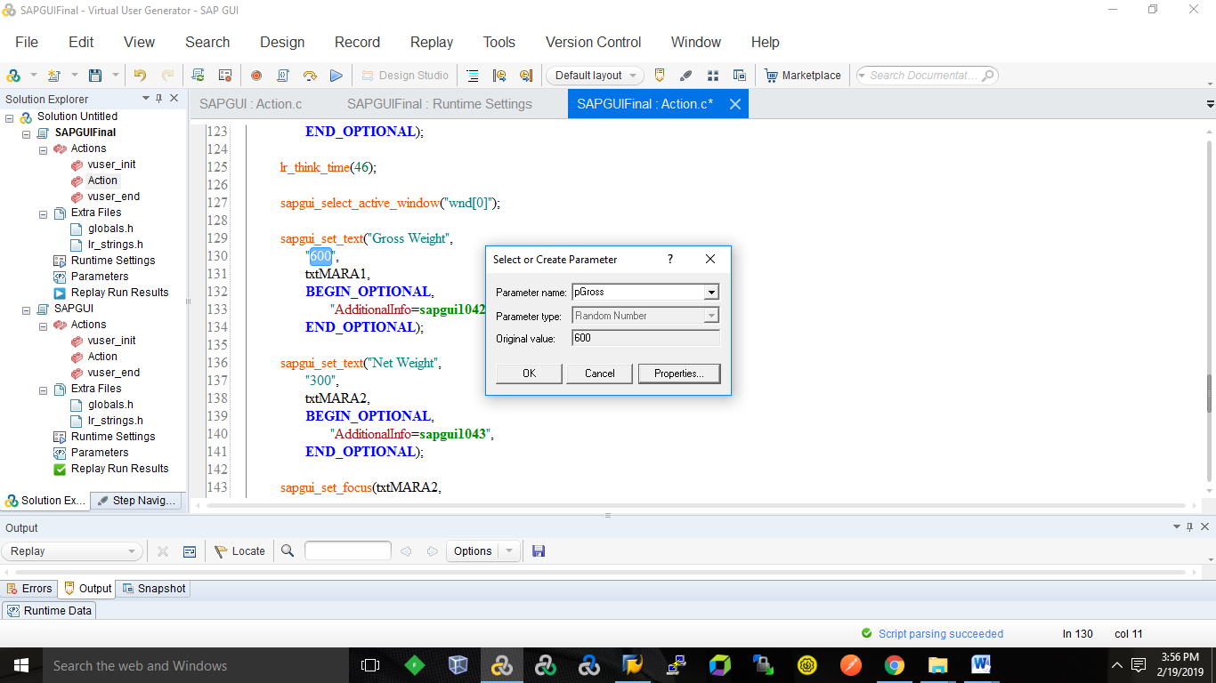

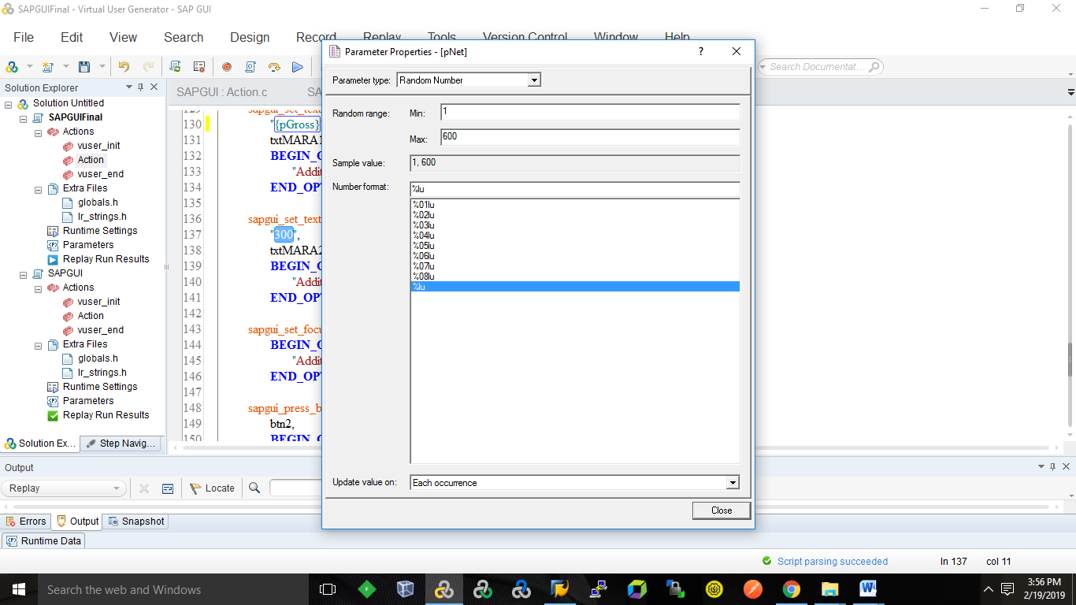

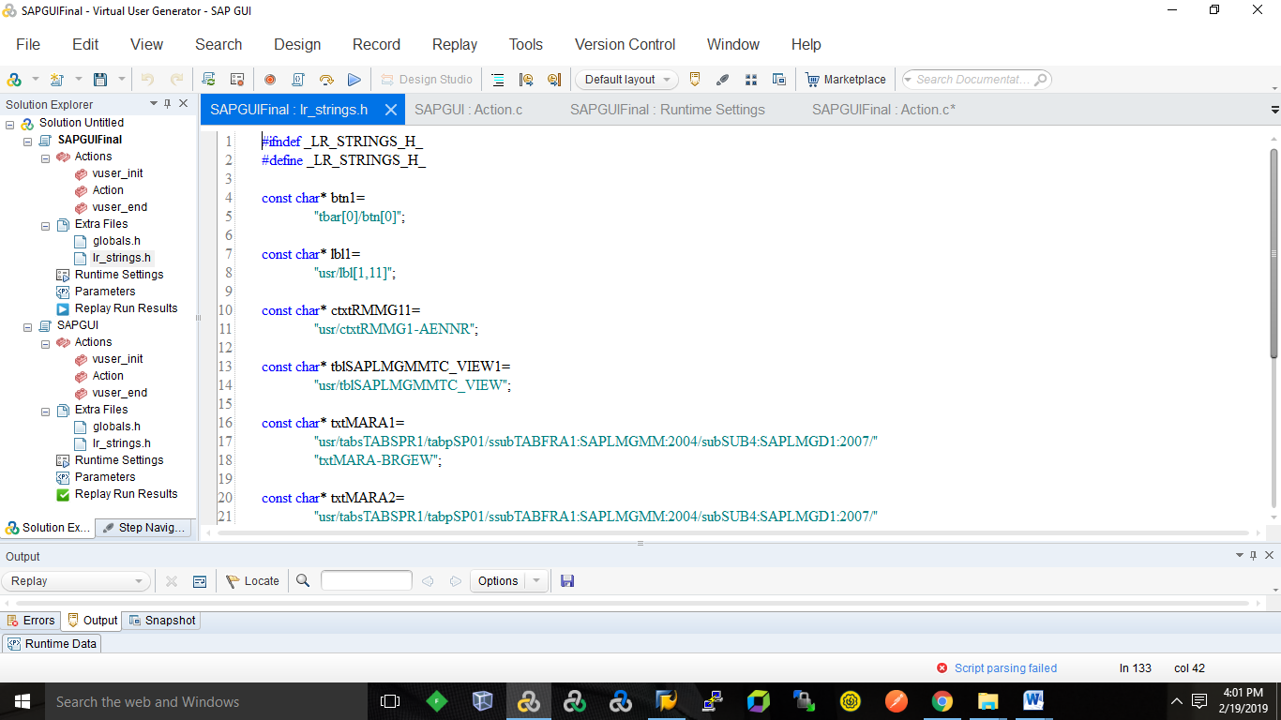

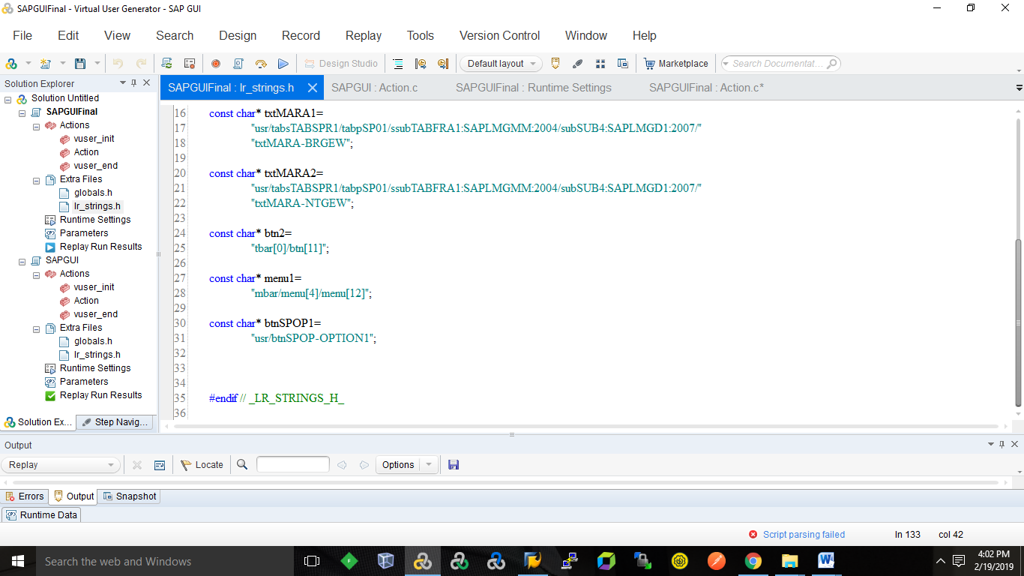

    sapgui_status_bar_get_text("paramStatusBarText",   
        **BEGIN_OPTIONAL**,   
            "Recorded status bar text: Material 1108 changed",   
            "AdditionalInfo=**sapgui1049**",   
        **END_OPTIONAL**);

sapgui_set_text("Gross Weight",   
        "{pGross}",   
        txtMARA1,   
        **BEGIN_OPTIONAL**,   
            "AdditionalInfo=**sapgui1042**",   
        **END_OPTIONAL**);

int **sapgui_get_text**( const char \**description*, const char \**controlID*, const char \**outParamName*, [*args*,] LAST );

    sapgui_set_text("Net Weight",   
        "{pNet}",   
        txtMARA2,   
        **BEGIN_OPTIONAL**,   
            "AdditionalInfo=**sapgui1043**",   
        **END_OPTIONAL**);

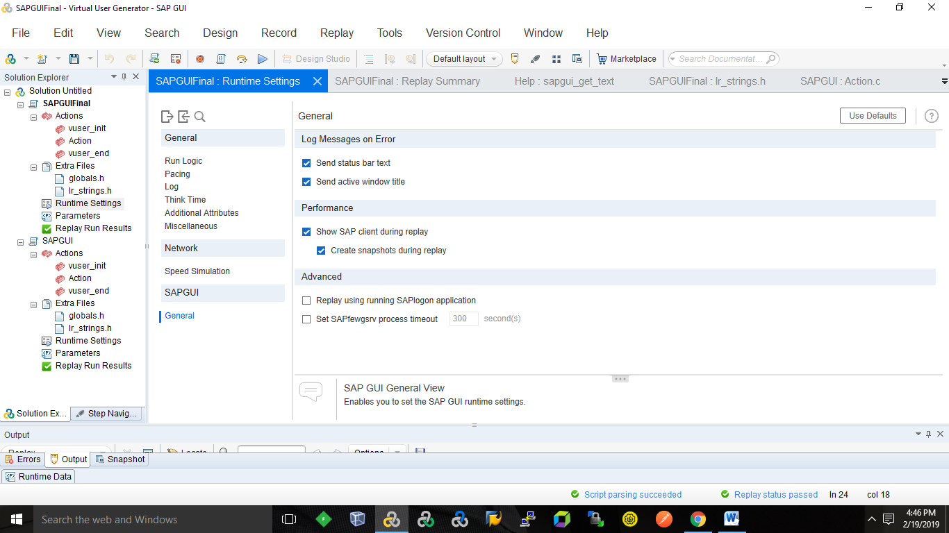

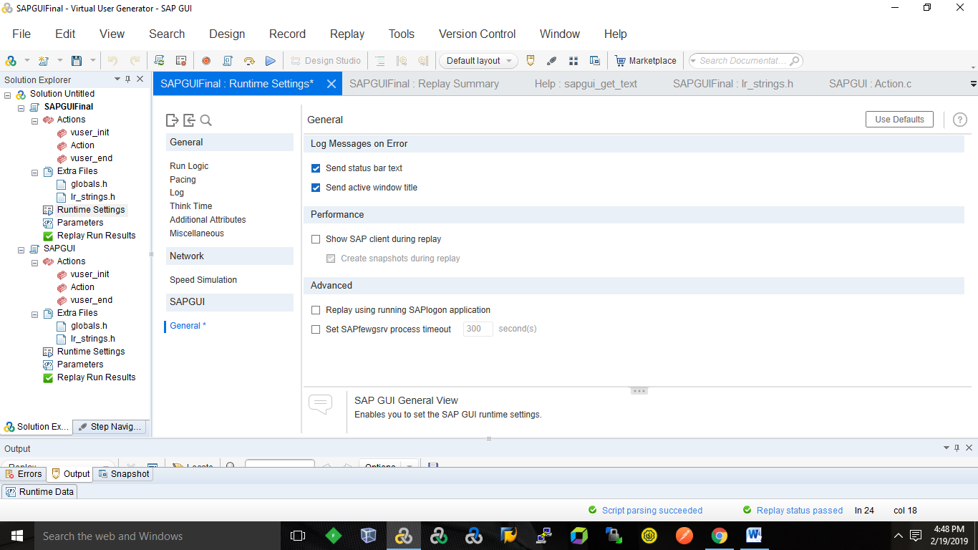

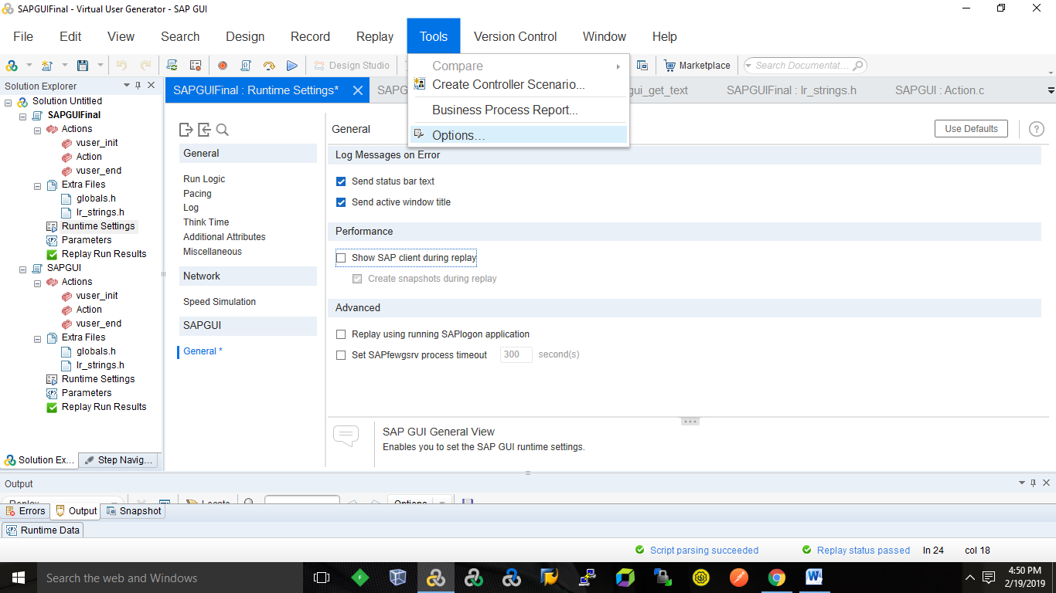

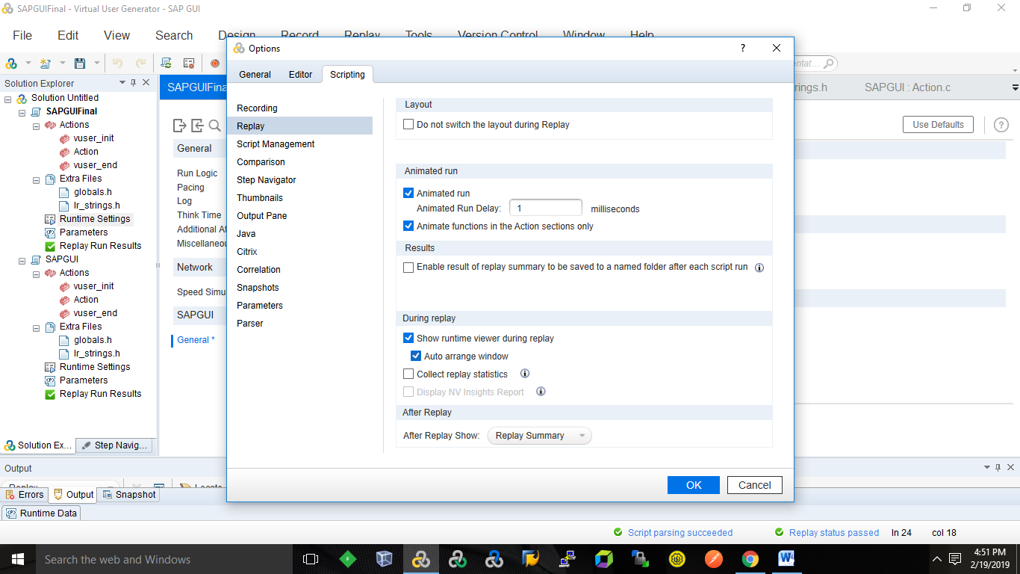

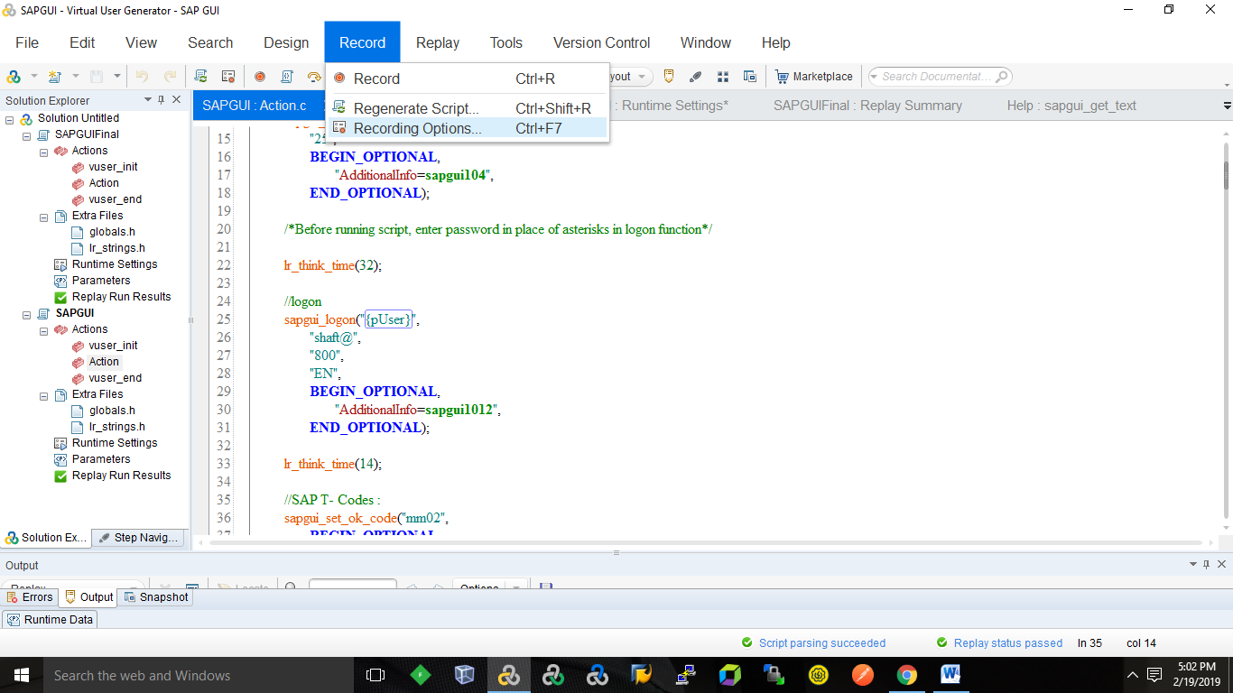

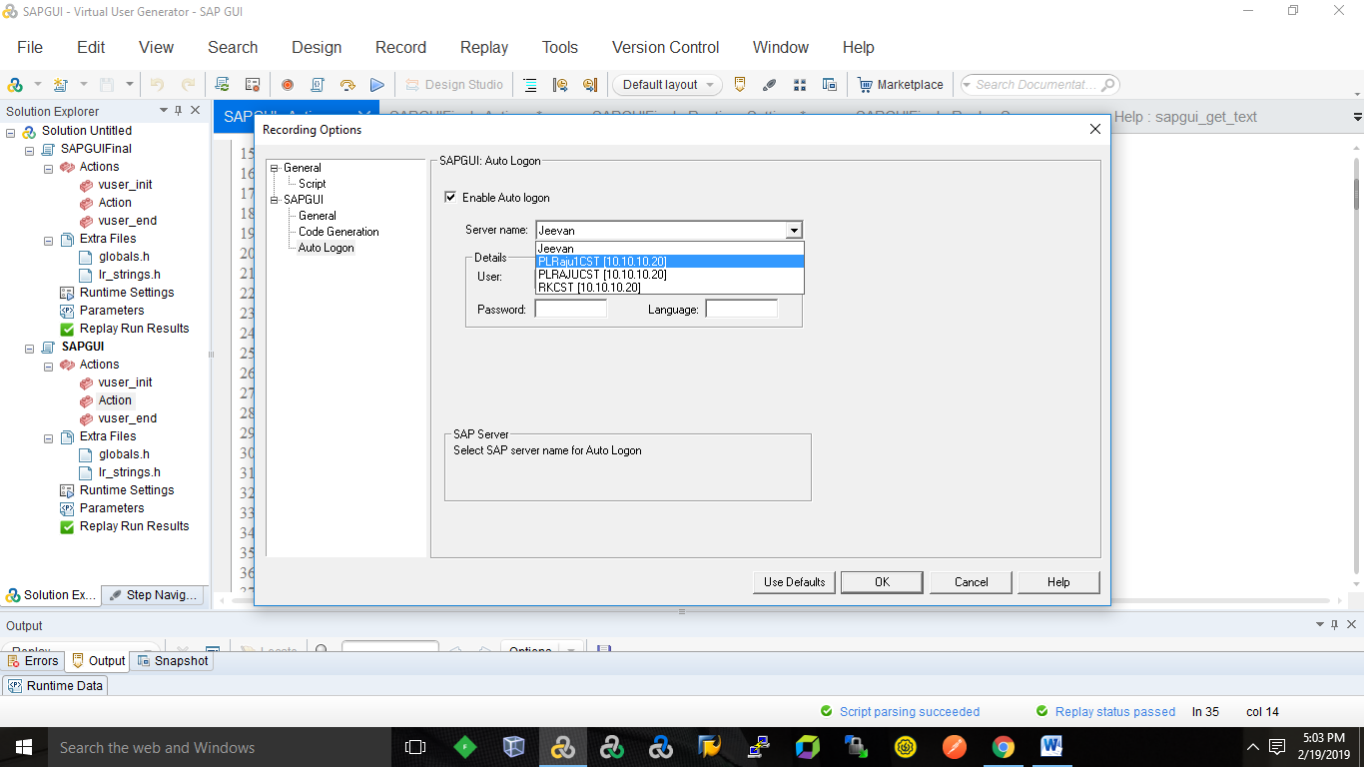

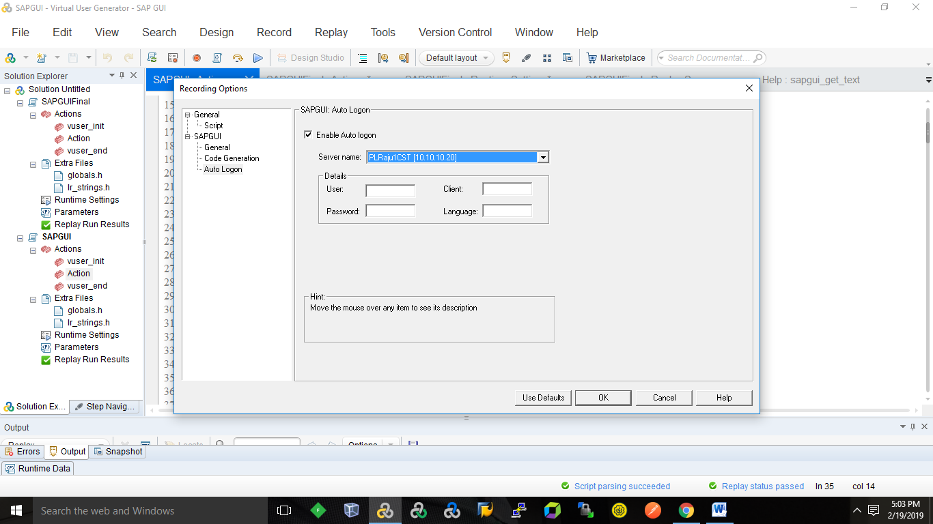

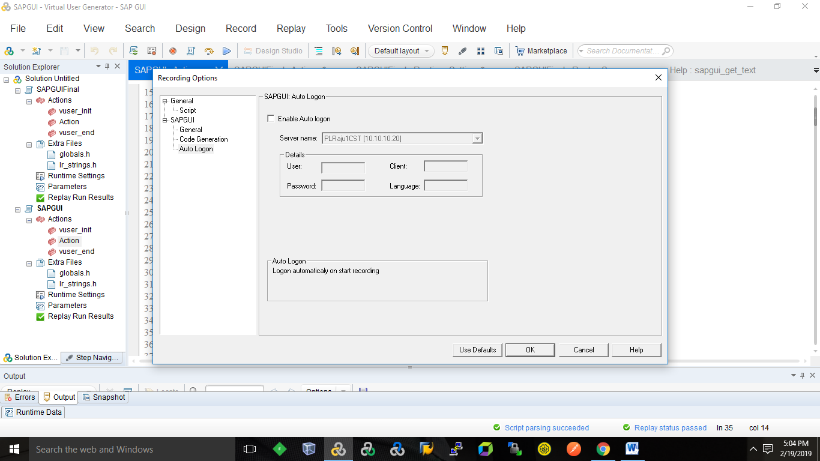

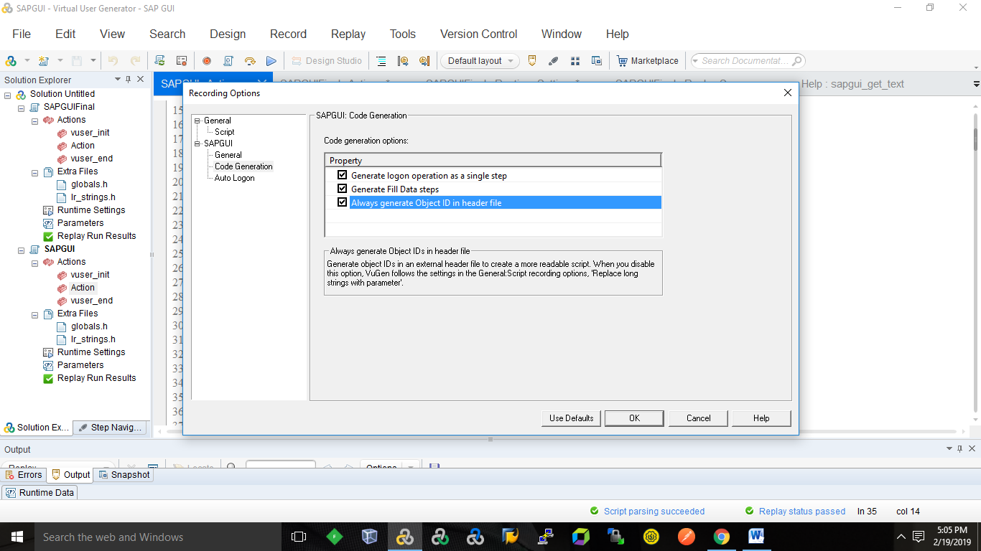

    sapgui_open_connection_ex("   /SAP_CODEPAGE=1100  /FULLMENU  {pServerName} 85 /3 /UPDOWNLOAD_CP=**2**",   
        "PLRAJUCST [10.10.10.20]",   
        "con[0]");

    sapgui_select_active_connection("con[0]");  
  
    sapgui_select_active_session("ses[0]");  
  
    sapgui_select_active_window("wnd[0]");

//logon  
    sapgui_logon("{pUser}",   
        "shaft@",   
        "800",   
        "EN",   
        **BEGIN_OPTIONAL**,   
            "AdditionalInfo=**sapgui1012**",   
        **END_OPTIONAL**);

    //SAP T- Codes :  
    sapgui_set_ok_code("mm02",   
        **BEGIN_OPTIONAL**,   
            "AdditionalInfo=**sapgui1013**",   
        **END_OPTIONAL**);

sapgui_send_vkey(**ENTER**,   
        **BEGIN_OPTIONAL**,   
            "AdditionalInfo=**sapgui1014**",   
        **END_OPTIONAL**);

    sapgui_send_vkey(**F4**,   
        **BEGIN_OPTIONAL**,   
            "AdditionalInfo=**sapgui1017**",   
        **END_OPTIONAL**);

sapgui_select_active_window("wnd[1]");  
  
    sapgui_press_button("Continue   (Enter)",   
        btn1,   
        **BEGIN_OPTIONAL**,   
            "AdditionalInfo=**sapgui1020**",   
        **END_OPTIONAL**);  
      
    //oject 01:  
    if (sapgui_is_object_available("tbar[0]/btn[0]", **LAST**)){  
        lr_output_message("oject 01:pass");  
    }else{  
        lr_output_message("oject 01:fail");  
    }

sapgui_window_scroll_to_row("0",   
        **BEGIN_OPTIONAL**,   
            "AdditionalInfo=**sapgui1024**",   
        **END_OPTIONAL**);  
  
    sapgui_set_focus(lbl1,   
        **BEGIN_OPTIONAL**,   
            "AdditionalInfo=**sapgui1023**",   
        **END_OPTIONAL**);

sapgui_table_set_row_selected(tblSAPLMGMMTC_VIEW1,   
        "1",   
        "True",   
        **BEGIN_OPTIONAL**,   
            "AdditionalInfo=**sapgui1036**",   
        **END_OPTIONAL**);  
  
    sapgui_table_set_focus("(1, 'View')",   
        tblSAPLMGMMTC_VIEW1,   
        "1",   
        "0",   
        **BEGIN_OPTIONAL**,   
            "OriginalID=**usr/tblSAPLMGMMTC_VIEW/txtMSICHTAUSW-DYTXT[0,1]**",   
            "AdditionalInfo=**sapgui1037**",   
        **END_OPTIONAL**);  
// Enter the text "600"  
  
    sapgui_set_text("Gross Weight",   
        "{pGross}",   
        txtMARA1,   
        **BEGIN_OPTIONAL**,   
            "AdditionalInfo=**sapgui1042**",   
        **END_OPTIONAL**);  
      
    //object 05:  
      
    if (sapgui_is_object_available("usr/tabsTABSPR1/tabpSP01/ssubTABFRA1:SAPLMGMM:2004/subSUB4:SAPLMGD1:2007/"  
        "txtMARA-NTGEW", **LAST**)){  
        lr_output_message("object 05:pass");  
    }else{  
        lr_output_message("object 05:fail");  
    }

/ Retrieve the text boxes   
    sapgui_get_text("Gross Weight",   
        "usr/tabsTABSPR1/tabpSP01/ssubTABFRA1:SAPLMGMM:2004/subSUB4:SAPLMGD1:2007/txtMARA-BRGEW", // Control ID  
        "grossParam",   
        **LAST** );  
    lr_output_message("%s", lr_eval_string("{grossParam}"));

    sapgui_press_button("Save   (Ctrl+S)",   
        btn2,   
        **BEGIN_OPTIONAL**,   
            "AdditionalInfo=**sapgui1046**",   
        **END_OPTIONAL**);

  //The text of the status bar is "Standard PO held under the number 4500010751".  
    //sapgui_status_bar_get_text("paramText", LAST );  
  
    sapgui_status_bar_get_text("paramStatusBarText",   
        **BEGIN_OPTIONAL**,   
            "Recorded status bar text: Material 1108 changed",   
            "AdditionalInfo=**sapgui1049**",   
        **END_OPTIONAL**);  
      
   // The value of parameter 1 in the status bar is "Standard PO".  
sapgui_status_bar_get_param("1", "param1", **LAST** );  
//The value of parameter 2 in the status bar is "4500010751".  
//sapgui_status_bar_get_param("2", "param2", LAST );  
  
//The value of "StatusBarType" after the call is "Success".  
sapgui_status_bar_get_type("StatusBarType", **LAST** );  
// Output is "Status of last action is 'Success'."  
lr_output_message("Status of last action is '%s'.",lr_eval_string("{StatusBarType}"));  
  
    lr_think_time(45);  
  
    sapgui_window_close(  
        **BEGIN_OPTIONAL**,   
            "AdditionalInfo=**sapgui1050**",   
        **END_OPTIONAL**);  
  
    sapgui_select_active_window("wnd[1]");  
  
    sapgui_press_button("Yes",   
        btnSPOP1,   
        **BEGIN_OPTIONAL**,   
            "AdditionalInfo=**sapgui1053**",   
        **END_OPTIONAL**);  
      
    //oject 08:  
    if (sapgui_is_object_available("usr/btnSPOP-OPTION1", **LAST**)){  
        lr_output_message("oject 08:pass");  
    }else{  
        lr_output_message("oject 08:fail");  
    }